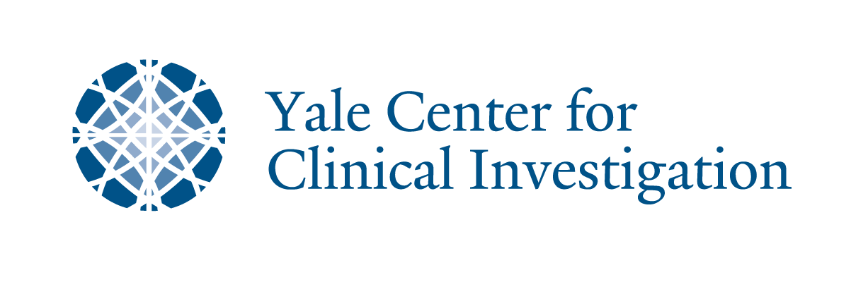
Innovation and Diversity Summit: Patient-centered Approaches to Care and Research
October 5, 2018
333 Cedar St in the Harkness Auditorium

7:00 AM – 7:55 AM Registration

7:55 AM – 8:00 AM Welcome
Robert Alpern, MD
Ensign Professor of Medicine; Dean, Yale School of Medicine

8:00 AM – 8:20 AM FDA Presentation
RADM Denise Hinton
Chief Scientist, FDA

8:20 AM – 9:05 AM Diversity and Innovation: The Yale Evolution
Allen Hsiao, MD, FAAP, Chief Medical Information Officer,
Yale School of Medicine & Yale New Haven Health

Tesheia H. Johnson
Associate Director, Clinical Research
Yale School of Medicine

9:05 AM – 9:35 AM FDA Presentation
CAPT Richardae Araojo
Associate Commissioner for Minority Health, FDA

9:35 AM – 9:50 AM Break

9:50 AM – 10:20 AM Historical perspective on Henrietta Lacks
Representatives from Henrietta Lacks’ family

10:20 AM – 10:50 AM Historical perspective on minorities in research
Quincy J. Byrdsong, EdD, CIP, CCRP
Executive Director for Research Administration
WellStar Research Institute

10:50 AM – 11:15 AM Regulatory perspectives
Linda Coleman, JD, CIP, CHC, CHRC, CCEP-I
Director, Human Research Protection Program
Yale University

11:15 AM – 12:15 PM Panel Discussion
Session moderator: Jovonni R. Spinner, MPH, CHES
Senior Public Health Advisor, FDA Office of Minority Health
Including Patient, FDA, NIH, Industry, Academia, Patient Advocates and Yale Cultural Ambassadors: Members of the African Methodist Episcopal Zion Church and Junta for Progressive Action

12:15 PM – 1:15 PM Lunch with and meeting the Lacks family

1:15 PM – 2:15 PM Community and Patient-centered approach to Cardiovascular Health and Research
Eric J. Velazquez. MD, FACP, FACC, FASE, FAHA
Professor of Medicine and Chief, Cardiovascular Medicine, Yale University

2:15 PM – 2:30 PM Closing and Wrap-up

