**Yale University School of Medicine**

med logo color

**Project ED Health II**

BNI Training

Manual



**PROJECT ED HEALTH II**

BNI Training Manual

Gail D’Onofrio MD, MS1

Michael V. Pantalon Ph.D.1

Linda C. Degutis DrPH1*

David Fiellin MD2

Patrick G. O’Connor MD2

1Department of Emergency Medicine, 2Department of Medicine, Section of General Internal Medicine

Yale University School of Medicine

New Haven, CT

*now at Centers for Disease Control and Prevention, Atlanta, GA

**© 2005 Project ED Health II Study - Yale University School of Medicine**

**Funded by National Institute on Alcohol Abuse and Alcoholism grant (1R01AA14963)**

**TABLE OF CONTENTS**

|  |  |
| --- | --- |
| **Overview of the Manual** | **4** |
| **Background Information** | **5-7** |
| **Overview of the BNI** | **8** |
| **Components of the BNI** | **9** |
| **Study Protocol** | **10** |
| **Emergency Practitioner Roles and Expectations** | **11-15** |
| **Additional Motivational Strategies** | **16** |
| **Common Problems** | **17** |
| **Figures and Tables** | **18-30** |
| **References** | **31-32** |

**I. Overview of the Manual**

This manual is designed to provide the Emergency Department (ED) practitioner with the necessary skills to easily and effectively perform a brief intervention, the Brief Negotiation Interview (BNI), with ED patients who have been identified as harmful or hazardous alcohol drinkers and enrolled in a Federally-funded randomized clinical trial testing the efficacy of the BNI as compared to Standard Care (SC). All subjects will have consented to participate in the study. The following sections provide background information and the goals of the study, and describe the critical components of the BNI. An easy to follow, step-by-step approach to performing the BNI is also included. The study protocol to be followed by ED practitioners (EPs) administering the BNI to subjects is provided along with additional motivational and troubleshooting strategies. While the manual gives the reader a critical overview of the BNI, participation in a 2-hour training course, followed by successful completing of a test case is required to be ready to begin enrollment. Periodic feedback and booster sessions will be offered during the course of enrollment to ensure effective and consistent performance.

**II. Background Information**

## **Introduction**

Unhealthy alcohol use[1] is a major preventable public health problem resulting in over 100,000 deaths each year [2] and costing society over 185 billion dollars annually.[3] The effects of unhealthy alcohol use have far reaching implications not only for the individual drinker, but also for the family, workplace, community, and the health care system.

**Prevalence**

There is a high prevalence of alcohol related problems in ED patients.[4],[5],[6] In specific populations such as trauma patients, alcohol has been shown to be a major contributing factor in up to 50% of major trauma cases[7] and 22% of minor trauma cases.[8] Therefore, the need for effective and practical interventions aimed at reducing the deleterious effects of drinking among harmful and hazardous drinkers that can be administered by ED practitioners, is critical.

**Spectrum of Alcohol Use/Terminology**

Patients presenting to the ED represent the entire spectrum of unhealthy alcohol-use as described in empirically-based guidelines from the National Institute of Alcohol Abuse and Alcoholism (NIAAA) illustrated in Figure 1.[9]  This includes hazardous drinkers who are at risk for injury and illness because they drink in excess of low-risk drinking guidelines to dependent drinkers. (See Table 1)

This study focuses on harmful and hazardous drinkers, including the hazardous (at-risk) drinker who exceeds the NIAAA consumption guidelines for low-risk drinking, but who is not currently experiencing any problems, and the harmful (problem) drinker, who is experiencing problems.[10]  These problems may be may be medical, such as injuries or illness; or behavioral such as driving while intoxicated. In the US, approximately 20% of individuals > 12 years of age fall into this category.[11] Harmful drinkers also include anyone presenting with an injury/illness related to alcohol even if the patient’s alcohol consumption does not exceed the NIAAA guidelines for low-risk drinking. For example, even 2 drinks may impair an individual’s reaction time and coordination, leading to consequences such as a motor vehicle crash (MVC), fall while dancing, etc.

**The BNI Works**

There is compelling evidence in the literature that screening and brief intervention (SBI) for alcohol problems is effective in reducing alcohol consumption and associated consequences.[12] An evidence-based review on SBI identified 39 published studies including 30 randomized controlled trials and 9 cohort studies.[13] A positive effect was demonstrated in 32 of these studies. Multiple studies have demonstrated the efficacy of BI in a variety of setting, including general populations, primary care, emergency departments and in-patient trauma care units.

To date there have been four randomized controlled studies specifically relevance to ED practitioners. (See Table 2) Two are specific to adolescents.

1. Adolescents with an alcohol-related events (2 Studies)

Monti et al,[14] compared usual care to the use of a brief motivational interview (MI) to reduce alcohol-related consequences and alcohol use among adolescents (aged 18-19 years) in an ED following an alcohol-related event. Follow-up assessments showed that both conditions decreased their alcohol consumption, but patients who received the MI had a significantly lower incidence of drinking and driving, traffic violations, alcohol-related problems (p <.05), alcohol-related injuries (p <.01) than those who received usual care. However, the generalizability of the results of this study may be limited because the population was limited to injured adolescents, all interventions were performed by trained social workers hired for the project, and there was a relatively high refusal rate. Monti’s results are similar to other BI in primary care settings[15] in that there were reductions in alcohol consumption in both groups, but a reduction in negative consequences in only the treatment group, and may suggest that a more intense intervention or associated booster may result in differences between conditions.

Spirito and colleagues[16] studied adolescents ages 13 to 17 who were treated in an ED for an alcohol-related event. The adolescents were eligible to participate in the study if they had evidence of alcohol in their blood, breath, or saliva (N = 142), or if they reported drinking alcohol in the 6 hours before the injury that required treatment in the ED (N = 10). The participants underwent a battery of assessments that took an average of 45 minutes to complete. They reported their drinking behavior over the past 12 months and completed the Adolescent Drinking Questionnaire (which assesses behavior over the past 3 month), the Young Adult Drinking and Driving Questionnaire, and the Adolescent Injury Checklist. Furthermore, at the beginning of the study the investigators administered the Adolescent Drinking Inventory (ADI) to identify adolescents with potential alcohol problems warranting a treatment referral and for use in the personal feedback component of the intervention condition.The ADI is a 24-item measure of severity of alcohol involvement, with a score of > 15 indicating that referral for alcohol problems is needed. Participants were then randomly assigned to receive standard care or a motivational interview.

Researchers interviewed the adolescents by phone after 3 months and contacted them in person after 6 and 12 months. The investigators found that adolescents in both groups drank less alcohol during the 12-month follow up period. However, adolescents in the MI group with a baseline ADI score indicating problematic alcohol use improved significantly in two outcomes, average number of drinking days per month (frequency) and frequency of high-volume drinking (binging). Based on these findings, the investigators recommend that adolescents who are treated in the ED for an alcohol-related injury should be screened for pre-existing alcohol problems and should receive a brief intervention if the screen is positive.

2. Injured Harmful/Hazardous (HH) Drinkers

Longabaugh and colleagues at Brown University published a clinical trial with injured, harmful/hazardous drinkers in the ED setting. Patients were randomized to standard care (SC), immediate BI, immediate BI followed by a booster or comprehensive intervention session subsequent to the ED visit (BIB). Patients receiving the BIB, but not BI patients, reduced alcohol-related negative consequences and alcohol-related injuries more than did those in the SC group. All three groups reduced their days of heavy drinking. This study demonstrates that a booster session may be helpful; however this study was limited to injured patients. However, 31% of patients actually assigned to return to the booster session in person did not return. It is possible that a booster session by telephone may be a better solution in ED populations. Their follow-up rate of 83% by phone would support this. However, translation to the real world setting is difficult as the intervention was lengthy, up to an hour, and performed by trained non-ED staff social workers. The demonstration of decreased drinking behavior in all three arms of this study raises the concern that lengthy research assessments, focused on alcohol-related behavior, may serve as an intervention or affect subject reporting. Of note, the generalizability of these findings are unclear because the number of patients who were eligible for the study but not randomized was not reported.

3. Admitted Trauma Patients

Gentilello, recently studied a subset of hospitalized trauma patients who screened and/or tested positively for the full spectrum alcohol problems, i.e., at-risk drinking to alcohol dependence. He reported a decrease in alcohol consumption in the intervention group who received a BI compared to control group (p<.03), which was most apparent in patients with mild to moderate problems (p<.01). In a 3 year follow-up period there was a 47% reduction in injuries requiring ED visit, and 48% reduction in injuries requiring hospital admission.(9) Among the methodological challenges in interpreting the results of this study is the spectrum of alcohol problems that patients presented with. The inclusion of alcohol dependent patients makes it difficult to compare this population with a heterogeneous ED population with only harmful and hazardous drinking. The generalizability of this study is somewhat limited by the fact that a single, doctorate level psychologist performed all of the interventions. Finally, follow-up rates were low, approximately 50% at 12 months.

**The ED Visit is an Opportunity for Intervention[17]**

Patients presenting to the ED are more likely to have alcohol-related problems than those presenting to primary care.[18] The ED visit offers a potential “teachable moment” due to the possible perceived negative consequences associated with the event.[19] In essence, the emergency practitioner has a captive audience.

**III. Overview of the BNI**

The BNI is a short, 5-7 minute counseling session that incorporates brief feedback and advice with motivational enhancement techniques to assist the patient in changing his/her drinking patterns.[20],[21], 12  In most cases this means lowering alcohol consumption to low-risk limits and thereby reducing the risk of illness/injury. The BNI procedure is patient-centered and the skills used are based in large part on the patient’s motivation and readiness to change. The primary product of the BNI procedure is the patient’s agreement to reduce either alcohol use or its ability to cause harm (medical problems or trauma). The practitioner and patient come to this agreement through a process of negotiation described in the following section.

### IV. Components of the BNI

The BNI procedure consists of 4 major steps:

1. **Raise The Subject**
   * Establish rapport
   * Raise the subject of alcohol use
2. **Provide Feedback**
   * Review patient’s drinking amounts and patterns
   * Make connection between drinking and ED visit (if applicable)
   * Compare patient’s level of drinking to national norms
3. **Enhance Motivation**
   * Assess readiness to change
   * Develop discrepancy between patient’s drinking and problems or

potential problems related to alcohol

1. **Negotiate And Advise**
   * Negotiate goal
   * Give advice
   * Summarize and complete drinking agreement

Each step has critical components, specific objectives, actions and necessary preparations to be successful. Details of each step are provided on pages 12 through 15. Prior to detailing the actual BNI procedure, it is important for the ED practitioner to know how the administration of the BNI coincides with the overall study protocol. A sample of the BNI dialogue appears in Table 9.

**V. Study Protocol**

**Study Period and Target Population**

This study will be conducted in the ED at Yale-New Haven Hospital (YNHH) for an estimated 3.5 years, beginning in July of 2005.

**Inclusion Criteria**

ED patients aged 18 and above, who screen positive for harmful and hazardous drinking are eligible for inclusion.

**Exclusion Criteria**

Excluded from the study will be patients who fall into any of the following categories:

* alcohol dependent (based on AUDIT score >19)
* non-English speakers
* currently enrolled in a substance abuse program
* seeking ED care for an acute psychiatric problem
* condition that precludes interview i.e., life threatening injury/illness
* in police custody
* unable to provide to 2 alternate contact numbers for follow-up

**Research Plan**

Patient eligibility will be determined by the study Research Associate (RA)

through a series of steps, based on the criteria listed above. 900 eligible and

consenting patients will be randomized to one of four study conditions by the RA;

2 groups will then complete an additional 20-30 minute baseline interview by telephone and receive a brief negotiated interview (BNI) performed by the ED Practitioner (EP). The RA will inform the EP when the patient is ready for the intervention. Every intervention will be audiotaped with subject consent. The RA will assist with recorder set-up and provide intervention aids (e.g., the BNI laminated reference card, BNI showcards, drinking agreement and patient health information handout). Following the intervention, the EP will be asked a few brief questions by the RA that should take less than one minute. The questions are designed to collect information on the ED practitioner’s medical care relationship with the patient, and details surrounding the intervention performed. After that, the RA will collect tape recorder with tape, study aids and carbon copy of the drinking agreement completed by the subject as part of the BNI.

**VI. Emergency Practitioner Roles and Expectations**

Enrolled patients will be randomized into one of four study groups. Once the patient has been consented and enrolled into the study, the RA will inform you if a BNI needs to be performed and provide you with the necessary materials. It is now the EP’s responsibility to complete the assigned intervention in a timely manner, prior to patient discharge. If you are not directly involved in the care of the patient, you will need to review the patient’s record prior to beginning the BNI. The intervention should be conducted in a timely manner in a climate as quiet and private as possible.

* **BNI Study Group**

The BNI should be performed exactly as outlined in the procedural steps. (REFER to the 4 steps on pages 12-15) It was designed to take approximately 5-7 minutes to complete. The intervention should conclude with the patient receiving a copy of the drinking agreement they have completed with you and a patient health information sheet. When finished, the RA will collect the audio tape recorder with tape and carbon copy of the drinking agreement. The RA will then ask you a few questions regarding the intervention lasting no longer than one minute.

**SUMMARY**

* Review ED record before seeing the study patient
* Perform the BNI in a timely fashion, aware of patient discharge plans
* Adhere to the BNI script
* Ensure quality audiotaping of BNI; keep recorder near conversation area
* Complete post-intervention debriefing with RA immediately after BNI
* Discuss any operational problems with Principal Investigator/Project Director

STEP1: Raise the Subject

**Critical components:**

1. Be respectful
2. Remember the patient giving you permission to discuss his/her alcohol use is an important aspect of the intervention
3. Avoid arguing or being confrontational

**PREPARATION:**

* Review ED record

|  |  |  |
| --- | --- | --- |
| **OBJECTIVES** | **ACTION(S)** | **QUESTIONS/COMMENTS** |
| Establish rapport | * Explain practitioner’s role * Avoid a judgmental stance * Set the climate | *“Hello, I am ____.”* |
| Raise the subject | * Engage the patient | *“Would you mind taking a few minutes to talk with me about your alcohol use?”* ***<PAUSE>*** |

**SUMMARY**

This first step sets the climate for a successful BNI. Asking permission to discuss the subject of alcohol formally lets the patient know that their wishes and perceptions are central to the treatment.

STEP2: Provide Feedback

**Critical components:**

1. Review current drinking patterns
2. Compare patient's drinking to national norms
3. Make the connection between alcohol and reason for ED visit or other medical problems (if applicable)

**PREPARATION:**

* Screening data provided by RA
* Charts & tables on norms provided by RA

|  |  |  |
| --- | --- | --- |
| **OBJECTIVES** | **ACTION(S)** | **QUESTIONS/COMMENTS** |
| Review patient’s  drinking patterns | * Review screening data * Express concern * Be non-judgmental | *“From what I understand you are drinking… ”*  *“We know that drinking above certain levels can cause problems such as … (refer to presenting ED problem, or, refer to future increased risk of illness and injury). I am concerned about your drinking.”* |
| Make connection to ED visit (if applicable) | * Discussion of specific patient medical issues e.g., MVC, GI complaints, hypertension | *“What connection (if any) do you see between your drinking and this ED visit?*  If patient sees connection, reiterate what they have said. If patient does not see connection, then make one using facts, e.g., (MVC). Then say, *“We know that our reaction time decreases even with one or two drinks. Drinking at any level may impair your ability to react quickly when driving.* |
| Compare to National norms | * Give NIAAA guidelines specific to patient sex and age | *“These are what we consider the upper limits of low risk drinking for your age and sex.* **[Show Guidelines & National Norms](See Tables 3 and 4)** *By low risk we mean that you would be less likely to experience illness or injury if you stayed within these guidelines.”* |

**SUMMARY**

Linking the ED visit to drinking and by comparing patient drinking patterns to National norms is a great motivator towards encouraging a change in the patient’s drinking pattern. This is the opportunity to offer education related to specific patient issues.

STEP3: Enhance Motivation

**Critical components:**

1. Assess readiness to change
2. Develop discrepancy
3. Reflective Listening
4. Open-ended questions

**PREPARATION:**

* "Readiness to Change Ruler" provided by RA
* Handouts of pros & cons for patient prompting (if needed) provided by RA

|  |  |  |
| --- | --- | --- |
| **OBJECTIVES** | **ACTION(S)** | **QUESTIONS/COMMENTS** |
| Assess readiness to change | * Have patient self-identify readiness to change, on a scale of 1-10 | **[Show Readiness Ruler] (See Table 5)** *“On a scale from 1-10, how ready are you to change any aspect of your drinking?”* |
| Develop discrepancy | * Identify areas to   discuss   * Use reflective   listening | If patient says:  - **> 2, ask “***Why did you choose that number*  *and not a lower one?”*  - **1 or unwilling, ask “***What would make*  *this a problem for you?* Or, “*How*  *important would it be for you to*  *prevent that from happening?”* Or,  *“Have you ever done anything you*  *wished you hadn’t while drinking?”*  - **Discuss pros and cons (See Table 6)**  Restate what you think the patient meant by his or her statement. For example, in the context of discussing drinking less with friends, the statement *“It’s difficult”*, maybe followed by, *“So it’s difficult because you’re worried about what your friends think”*, delivered with downward intonation. |

**SUMMARY**

Patients are often ambivalent about change. Developing discrepancies between the patient’s present behavior and their own expressed concerns may tip the scales towards readiness to change. Reflective listening is a way in which to check what the patient meant by a statement. Intonation should turn down at the end of the remark to encourage patient response.

STEP4: Negotiate and Advise

**Critical components:**

1. Negotiate a plan on how to cut back and/or reduce harm
2. Direct advice
3. Drinking Agreement and patient health information handout

**Preparation:**

* Drinking Agreement provided by RA
* Patient health information handout provided by RA

|  |  |  |
| --- | --- | --- |
| **OBJECTIVES** | **ACTION(S)** | **QUESTIONS/COMMENTS** |
| Negotiate goal | * Assist patient to identify a goal from a menu of options * Avoid being argumentative | Reiterate what pt says in Step 3 and say, *“What’s the next step?”* |
| Give advice | * Deliver sound medical   advice/education   * Harm reduction | *“If you can stay within these limits you will be less likely to experience (further) illness or injury related to alcohol use.”* |
| Summarize | * Provide a drinking agreement * Provide health information sheet | *“This is what I have heard you say…Here is a drinking agreement I would like you to fill out, reinforcing your new drinking goals. This is really an agreement between you and yourself”*  **Provide:**  **- Drinking agreement (See**  **Table 7; pt keeps 1 copy;**  **1 copy for study)**  **- Provide Health Information**  **Handout (See Table 8)**  Suggest Primary care f/u for drinking level/pattern. Thank patient for his/her time. |

**SUMMARY**

The EP should assist the patient in exploring a menu of options. However, the patient is the decision-maker and should ultimately be responsible for choosing a plan.

**VII. Additional Motivational Strategies**

* **Refrain From Directly Countering Resistance Statements**

For example, the patient may say “How can I have a drinking

problem when I drink less than all my buddies?” You can reply

without insisting that there is a problem per se, but rather an issue

that is worthy of further assessment and discussion, within the

context of this brief interview.

* **Focus On The Less Resistant Aspects Of The Statement**

For example, the above patient may be wondering about how much drinking is considered to be problematic. The response might be to restate his concern and ask about his level of drinking, which is the less resistant part of the statement. “It sounds like you’re confused about how you could have an issue with your drinking if you drink less than all your friends. I’d like to explain this to you.” (*And remember, this is a statement NOT a question, so the intonation should turn down at the end of the remark*).

* **Restate Positive or Motivational Statements**

For example, if a patient says: “You know, now that you mention it,

I feel like I have been overdoing it with my drinking lately,” the EP

could say, “You don’t need me to tell you you’ve been drinking a little too much lately, you’ve noticed yourself.”). This serves to reinforce the patient’s motivation-even if the motivational statement is a relatively weak one. If the patient says, “I guess I might have to change my drinking” this could be restated as “It sounds like you’ve been thinking about changing”.

* **Other Helpful Hints**

Encourage patients to think about previous times they have cut back on their drinking.

Praise patients for their willingness to discuss such a sensitive

topic, as well as their willingness to consider change.

View the patient as an active participant in the intervention.

**VIII. Common Problems**

Certain problems may occur during the course of the intervention steps….

* **Refusal To Engage In The Discussion Of The Topic Of Drinking**

Most patients will agree to discuss the topic, because they have already consented to be in the study, but in the unlikely event that someone outright refuses to discuss it at all, tell the patient that you will respect their wishes and that all you will be doing is giving him 3 pieces of information:

1. His drinking exceeds low-risk drinking limits (or is harmful);

2. Low-risk drinking limits recommended for pts age and sex; and,

3. You are concerned and that s/he should cut down to low-risk

drinking limits to avoid future harm (Steps 2 and 4 only).

* **Refusal To Self-Identify Along The Readiness Ruler**

When this happens, it is usually a problem with understanding the numbers. There are several ways of dealing with this:

1. Anchor the numbers with descriptors, such as “1” means not ready

at all or 0 per cent ready, and 10 means completely ready or 100%

ready to change.

1. Ask “What would make this a problem for you?” Or, “How important

is it for you to change any aspect of your drinking?”

1. Discussion of Pros and Cons (refer to list).

* **Unwilling To Associate Visit With Alcohol Use**

Don’t force the patient to make the connection, but be sure that he/she hears that in your medical opinion there is a connection. However, this connection may not be the thing that ultimately motivates the patient to change. If this happens try to find some other negative consequence of drinking that the patient can agree is related to alcohol and bothersome enough to consider drinking less.

* **Not Ready To Change Drinking Patterns Into Safe Limits**

Tell the patient that the best recommendation is to cut back to low-risk drinking limits, but that any step in that direction is a good start. The patient’s goal is then written on the drinking agreement. Regardless of the individual goal, the patient also receives the practitioner’s advice for low-risk drinking on the patient health information handout.

FIGURE 1: THE SPECTRUM OF ALCOHOL USE21



*Low-Risk*

*35%*

TYPES OF DRINKERS:

Abstainers Drink no alcohol.

Low-risk Drink within NIAAA guidelines. Alcohol use does not

affect health or result in problems.

Hazardous (At Risk) Exceed NIAAA consumption guidelines. Alcohol use

puts them at risk for injury/illness or social problems.

Harmful (Problem) Currently experiencing problems (medical/social)

related to alcohol; often exceed NIAAA guidelines for

low-risk drinking.

Dependent Physically dependent on alcohol (experience

withdrawal symptoms); meet criteria for dependence

based upon assessment criteria such as DSM-IV.

TABLE 1: NIAAA LOW-RISK DRINKING GUIDELINES

|  |  |  |
| --- | --- | --- |
| **# STANDARD DRINKS FOR**  **LOW-RISK DRINKING** | | |
|  | **Per**  **Week** | **Per Occasion** |
| **Men** | 14 | 4 |
| **Women** | 7 | 3 |
| **All > 65** | 7 | 3 |

**WHAT IS A STANDARD DRINK?**

**1 Standard Drink equals:**

j0291044 **or**j0291061 j0291052 j0291047

drink made with 1.5 oz. 12 oz. Beer 5 oz. wine

of alcohol (whiskey, gin, etc.)

TABLE 2: CLINICAL STUDIES OF SBI **[22]**

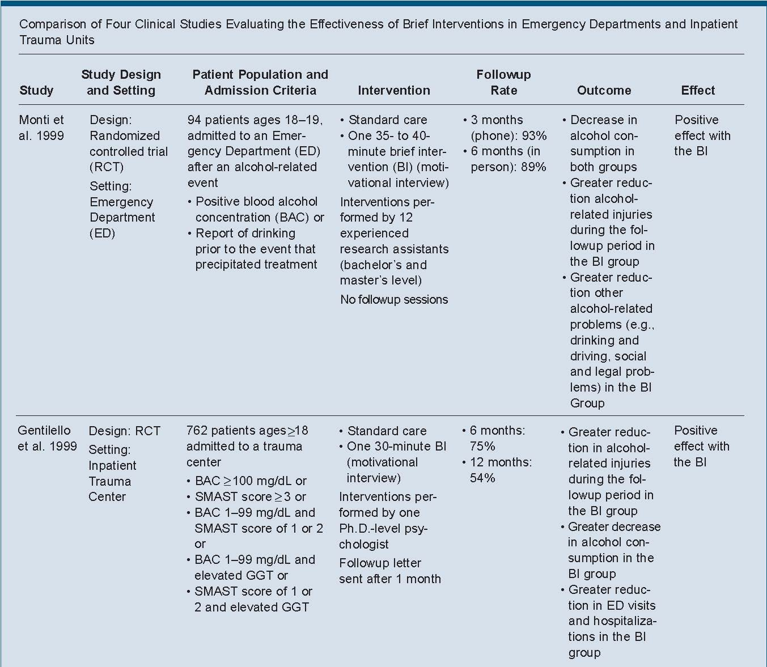

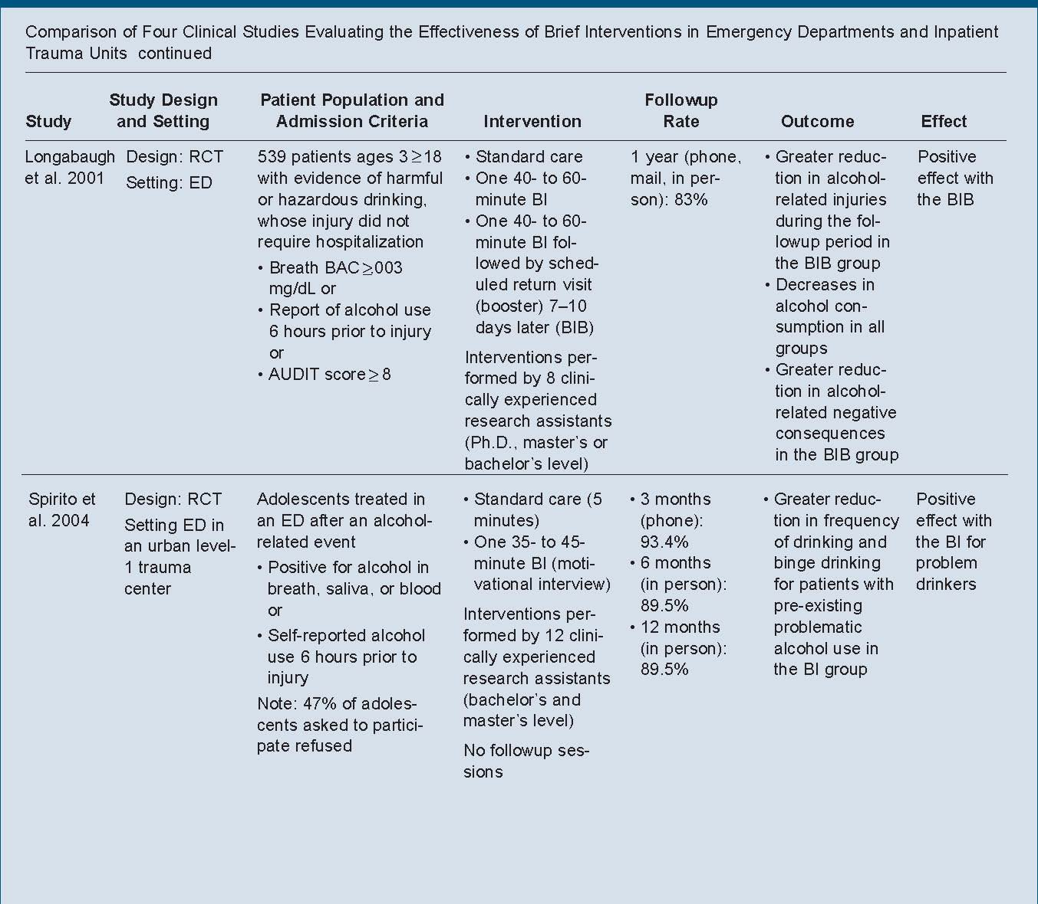TABLE 3: GUIDELINES

(Referred to in Step 2)

**NIAAA GUIDELINES FOR LOW-RISK DRINKING:**

|  |  |  |
| --- | --- | --- |
| **# Standard Drinks for**  **Low-Risk Drinking** | | |
|  | **Per Week** | **Per Occasion** |
| Men | 14 | 4 |
| Women | 7 | 3 |
| All age >65 | 7 | 3 |

WHAT IS A STANDARD DRINK?

**1 Standard Drink equals:**

j0291044 **or**j0291061 j0291052 j0291047

drink made with 1.5 oz. 12 oz. Beer 5 oz. wine

of alcohol (whiskey, gin, etc.)

**TYPES OF DRINKERS:**



*Low-Risk*

*35%*

TABLE 4: NATIONAL NORMS

(Referred to in Step 2)

**Alcohol Consumption Norms for U.S. Adults**

___________________________________________

Drinks per week Total % % Men % Women

0 35 29 41

1 58 46 68

2 66 54 77

3 68 57 78

4 71 61 82

5 77 67 86

6 78 68 87

7 80 70 89

8 81 71 89

9 82 73 90

10 83 75 91

11 84 75 91

12 85 77 92

13 86 77 93

14 87 79 94

15 87 80 94

16 88 81 94

17 89 82 95

18 90 84 96

19 91 85 96

20 91 86 96

21 92 88 96

22 92 88 97

23-24 93 88 97

25 93 89 98

________________________________________________

Source: 1990 National Alcohol Survey, Alcohol Research

Group, Berkeley, Courtesy of Dr. Robin Room

TABLE 5: READINESS RULER

(Referred to in Step 3)

READINESS RULER

Not ready Very ready

1 2 3 4 5 6 7 8 9 10

TABLE 6: PROS AND CONS

(Referred to in Step 3)

**Reasons to Quit or Cut Down on Drinking**

To live longer, and feel better

To consume fewer empty calories (alcohol has no nutritional value)

To sleep better

To be less likely to have a stroke

To improve blood pressure control

To reduce the possibility of death from liver disease

To prevent problems with medications

To decrease the likelihood of falls or other injuries

To prevent memory loss that may lead to loss of independence

To be able to care for myself longer

To be a better parent or grandparent

To reduce the possibility that I will die in a car crash

Other reasons:___________________________

TABLE 7: DRINKING AGREEMENT

**Reasons for Drinking**

I enjoy the taste

It enhances meals

For pleasure in social situations

To more easily socialize

Other people expect that I will drink with them

To relax or relieve stress

To cope with feelings of anger

To cope with feelings of boredom

To deal with momentary feelings of depression

To deal with momentary feelings of loneliness

To deal with feelings of frustration

To relieve the stress of arguments with family members or friends

It’s something I do when I’m smoking

It’s something I do when I’m watching T.V.

It’s something I do with certain friends or relatives

To help me sleep

To relieve pain

To make me feel better

Other reasons:____________________

(Referred to in Step 4)

**DRINKING AGREEMENT**

Date:___________________

I, ______________________________, agree to the following drinking limit:

Number of drinks per week: _______________________________________

Number of drinks per occasion: _______________________________________

Patient signature: _____________________________________________

**Remember: It is never a good idea to drink and drive and it’s**

**Illegal to drink if you’re under the age of 21.**

TABLE 8: HEALTH INFORMATION HANDOUT

(Referred to in Step 4)

**(FRONT)**

**Please read the following important information, about reducing risky health behaviors, which may apply to you.**

|  |  |  |
| --- | --- | --- |
| **Health Risk** | **What we know…** | **What you can do…** |
| **Smoking** | * It’s not healthy to smoke. * There are many options available to help you stop. | We recommend that you speak with your primary care physician for his or her advice.   * Or you may call: (203) 688-9999 [8-5; M-F] |
| **Exercise** | * It’s healthy to exercise on a regular basis. * The amount of exercise recommended on a daily basis is 30 minutes. | We recommend that you speak with your primary care physician for his or her advice.   * + Or you may call:   (203) 688-9999 [8-5; M-F] |
| **Alcohol Use** | * Drinking above low risk limits will increase your risk for illness and/or injury. * Please see the drinking information for your sex and age, on the back of this paper. * It’s never good to drink and drive. | We recommend that you speak with your primary care physician for his or her advice.   * + Or you may call:   (203) 688-9999 [8-5; M-F] |
| **Safety Issues** | * It is always healthy to take safety precautions. * Always use a seatbelt when in a car. * Always wear a helmet while biking, riding a motorcycle or rollerblading. | We recommend that you speak with your primary care physician for his or her advice.   * + Or you may call:   (203) 688-9999 [8-5; M-F] |

**(BACK)**

**WHAT IS A STANDARD DRINK?**

**1 Standard Drink equals:**

j0291044 **or**j0291061 j0291052 j0291047

mixed drink made with 12 oz. Beer 5 oz. wine

1.5 oz. of alcohol

(whiskey, gin, etc.)

1 glass of wine

5 oz.

1 regular beer

12 oz.

**HOW MUCH IS TOO MUCH?**

If you drink more than this you can put yourself at risk for illness and/or injury:

**# Drinks**

**Week** **Occasion**

Men 14 4

Women 7 3

All age >65 7 3

**Sometimes even 1 drink is too much!** If you are:

* + - driving or planning to drive
    - at work or returning to work
    - pregnant, or breast feeding
    - on medication
    - have certain medical conditions

TABLE 9: CASE EXAMPLE OF BNI DIALOGUE

|  |  |  |
| --- | --- | --- |
| **SPEAKER** | **DIALOGUE** | **PROCEDURE** |
| Physician | Hello, I am Dr. Jones. Would you mind spending a few minutes talking about your use of alcohol? | **RAISE THE SUBJECT** |
| Patient | Ok, like what? |  |
| Physician | From what I understand you were drinking tonight and were involved in a car crash. You told the nurse that you drink 2-3 days a week and usually have 6-8 beers per occasion. I am concerned because that level of drinking can put you at risk for illness or injuries, such as why you are here today.  What connection do you see between your drinking and this ED visit? | **PROVIDE FEEDBACK**  Make Connection |
| Patient | None really. I mean, I really had the right of way. I had a few beers. What is the problem with that? I can hold my alcohol well. He ran into me. You know that intersection between Grand and College Ave. I was going south on College and he just smacked right into me. I didn’t see him at all. I am in kind of a rush. I need to get out of here, but it wasn’t my fault |  |
| Physician | I believe that is was not your fault. I know that busy intersection. However we know that drinking even small amounts such as 1 or 2 drinks can reduce your reaction time. As you know, we avoid crashes almost every day. Drivers run stop signs, backup without looking etc. At that very intersection there are near- misses everyday. Do you think that you might have seen that other car approaching and avoided the crash if you had not been drinking? I don’t know for sure, I was not there, but it is one thing I would like you to consider. |  |
| Patient | Well, I said that I didn’t see him at all. I didn’t see him until the crash |  |
| Physician | So one thing, you might have seen him if you weren’t drinking any amount. It is clear that legally you had the right of way. I am also concerned about the amount you drink. Based on a large amount of research and national information we know that if you drink above certain levels puts you at risk for injuries and illness. For your age and sex that means the upper limits of low risk drinking are no more than 14 drinks per week, and no more than 4 drinks on any occasion. A standard drink is one 12 ounce can of beer, 5 ounces of wine or 1 ½ ounces of distilled spirits. | Show NIAAA guidelines |
| Patient | Yeah, I guess I am over that. |  |

|  |  |  |
| --- | --- | --- |
| **SPEAKER** | **DIALOGUE** | **PROCEDURE** |
| Physician | Well now that we have discussed the risks of further injury when drinking over the recommended amounts, how ready are you to change any aspect of your drinking? | **ENHANCE MOTIVATION**  Readiness to change |
| Patient | I don’t know, maybe a 5 |  |
| Physician | OK, so that is good, you are halfway or 50% there. Why not less? In other words why did you not pick a 1 or 2? What are some reasons why you think some changes need to be made? | Develop discrepancy |
| Patient | Well, I am here I guess, and I can tell that my neck and back are really going to hurt tomorrow. But I really do like to drink with my friends. Normally I do not drink and drive, but I needed to be somewhere after, so I drove myself. |  |
| Physician | So you already know that drinking and driving is not a good idea and that was a rare event for you. But rare events can sometimes lead to consequences, like today. So I guess you are ready because you don’t think that it’s a good idea to drink and drive. On the other hand you enjoy drinking with your friends. Any disadvantages to that? | Reflection |
| Patient | We normally go out on Friday and Saturdays. Sometimes on Thursdays and then I’m a little late to work on Friday. It takes the morning and lots of coffee to clear my head. |  |
| Physician | So what I hear your saying is that there are two reasons why you are dissatisfied with your drinking. First is that you ended up in the ED and will probably have some muscles aches and pains for a few days, and second that sometimes you are slow at work. That could cause you trouble I suspect with your boss. In addition I have given you some information regarding the risks of drinking over the recommended limits. So, where does that leave you now? (or what is the next step?) What agreement could you make between you and yourself regarding your drinking levels? | **NEGOTIATE & ADVISE**  Summarize  Negotiate goal |
| Patient | Well, I’m definitely not going to drink and drive. That is a big deal because even though I thought I could, I probably can’t. I don’t know about the limits. I can stay within 14 a week, but I don’t know about the 4 at a time. I will try but it is often a long game we are watching. |  |
| Physician | So no more drinking and driving, and you are going to try to keep it to 4 beers per occasion, knowing that it’s tough at times but you are willing to try. |  |
| Patient | OK |  |
| Physician | Good luck. I would also recommend that you follow-up with your primary care doctor and discuss how you are doing with the agreement.  Thanks for your time | Follow-up  Thank patient |

**References**

1. Saitz, R. Clinical Practice. Unhealthy Alcohol Use. New England Journal of Medicine

   352 (6): 596-607, 2005.
2. McGinnis JM, Foege WH. Actual causes of death in the United States.

   JAMA. 1993;270:2207-12.
3. Harwood HJ. Updating Estimates of the Economic Costs of Alcohol Abuse

   in the United States: Estimates, Update Methods and Data. Report prepared

   by the Lewin Group for the National Institute on Alcohol Abuse and

   Alcoholism, 2000.
4. Cherpitel C. Alcohol and violence-related injuries: an emergency room

   study. Addiction.1993;88:79-88.
5. Whiteman PJ, Hoffman RS, Goldfrank LR. Alcoholism in the emergency

   department: An epidemiologic study. Acad Emerg Med 2000;7:14-20.
6. Bernstein E, Tracy A, Bernstein J, Williams C. Emergency department

   detection and referral rates for patients with problem drinking. Subst Abuse.

   1996;17:69-76.
7. Rivara FP, Jurkovich GJ, Gurney JG, et al. The magnitude of acute and

   chronic alcohol abuse in trauma patients. Arch Surg 1993;128:907-912.
8. Degutis LC. Screening for alcohol problems in emergency department

   patients with minor injury: results and recommendations for practice and

   policy. Contemp Drug Probl. 1998;25:463-467.
9. National Institute on Alcohol Abuse and Alcoholism. The Physician’s Guide

   to Helping Patients with Alcohol Problems. U.S. DHHS NIH Publ. No. 95-3769. Washington, DC: PHS 1995.
10. O’Connor PG, Schottenfeld RS. Patients with alcohol problems. N Engl J

    Med. 1998;9:593-602.
11. Secretary of Health and Human Services. Ninth Special Report to Congress

    on Alcohol and Health. National Institute on Alcohol Abuse and Alcoholism.

    Rockville, MD: Department of Health and Human Services, 1997.
12. D’Onofrio, G, Pantalon, MV, Degutis, LC, Fiellin, DA, O’Connor, PG.

    Development and Implementation of an Emergency Practitioner-Performed Brief Intervention for Hazardous and Harmful Drinkers in the Emergency Department Acad Emerg Med. 2005; 12: 249-256.
13. D’Onofrio G, Degutis LC. Screening and brief intervention for alcohol

    problems in the emergency department: a systematic review. Acad Emerg

    Med. 2002;9:627-638.
14. Monti PM, Spirit A, Mers M, Colby SM, Barnett NP, Rohsenow DJ, Woolard

    R, Lewander W. Brief intervention for harm reduction with alcohol-positive older adolescents in a hospital emergency department. Journal of Consulting and Clinical Psychology. 1999;67:989-94.
15. Chick J, Lloyd G, Crombie E. Counseling problem drinkers in medical wards: A

    controlled study. British Medical J. 1985;290:965-967.
16. Spirito, A.; Monti, P.M.; Barnett, N.P.; et al. A randomized clinical trial of a brief

    motivational intervention for alcohol-positive adolescents treated in an emergency department, Journal of Pediatrics 145:396-402, 2004.
17. D’Onofrio G, Bernstein E, Bernstein J, Woolard RH, Brewer PA, Craig SA, Zink BJ. Patients with alcohol problems in the emergency department, Part1: improving detection. Acad Emerg Med 1998;5:1200-1209.
18. Longabaugh R, Minugh PA, Nirenberg TD, Clifford PR, Becker B,

    Woolard RH. Injury as a motivator to reduce drinking. Acad Emerg Med. 1995;2:817-825.
19. D’Onofrio G, Bernstein E, Bernstein J, Woolard RH, Brewer PA, Craig SA, Zink BJ. Patients with alcohol problems in the emergency department, Part 2: Intervention and referral Acad Emerg Med 1998;5:1210-1217.
20. D’Onofrio G, Bernstein E, Rollnick S. Motivating Patients for Change: A Brief Strategy for Negotiation. In: Bernstein E and Bernstein J. (eds.) *Emergency Medicine and the Health of the Public.* Boston: Jones and Bartlett; 1996:51-62.
21. Broadening the base of treatment for alcohol problems: report of a study by

    a committee of the Institute of Medicine. Washington, D.C.: National

    Academy Press, 1990.
22. D’Onofrio G, Degutis L. Screening and Brief Intervention in the Emergency

    Department, Alcohol Health and Research World 2005, in-press.