Post-Graduate Positions in Eating Disorder and Obesity Clinical Research
Yale University School of Medicine
The Department of Psychiatry at the Yale School of Medicine is seeking qualified candidates for clinical research opportunities in eating disorders and obesity. These positions are ideal for individuals who recently graduated from bachelor’s or master’s programs (“post-grad”) and intend to pursue doctoral training in clinical/health/counseling psychology. The positions provide experiences in patient-oriented research. Positions involve working closely with faculty (licensed psychologists) and pre- and post-doctoral clinical-researchers in the Program for Obesity, Weight, and Eating Research (POWER) at Yale.
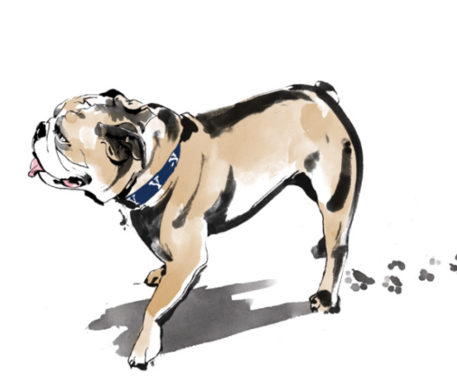
"Post-grads" will be involved in activities related to treatment studies, which are funded by NIH grants and foundation grants. These activities include study recruitment, pre-clinical interviews (screening), management of participants’ health data and research files, participant retention, and coordination and consultation with interdisciplinary treatment teams. Although the majority of our clinical trials focus on adults, one post-grad position will have additional focus on children. Experiences will prepare individuals well and increase their competitiveness for psychology PhD programs and MD or MD/PhD programs.
“Post-grads” will be encouraged to attend Yale educational activities (e.g., grand rounds, lectures, workshops) that provide exposure to leading clinical-researchers, emerging research developments, and provide relevant instruction on clinical-research studies.
Other mentored opportunities, including clinical or research activities, may be possible depending on candidates’ training goals. These positions are full-time and require a one-year commitment (with option to extend for up to one additional year). Payment is competitive and commensurate with Yale post-graduate associate salary guidance.
For more information about Yale POWER, please see our websites (power.yale.edu and m.yale.edu/teenpower)
Start dates are flexible and can begin June or July 2021. It is recommended that candidates submit application materials by 12/19/21. Interested candidates should send a CV and statement of interests and career goals (reference letters will be requested after initial review) by email to: Dr. Janet Lydecker (janet.lydecker@yale.edu).

