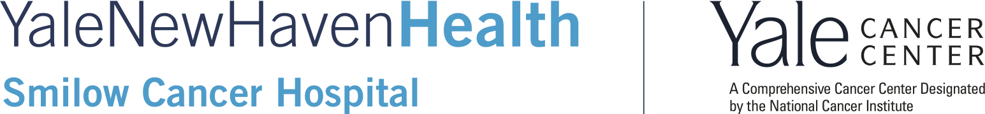

Yale’s Review of Advances in Oncology:
Highlights from the ASCO Annual Meeting 2025
Friday, June 26, 2026
New Haven Lawn Club

Course Director: Roy S. Herbst, MD, PhD
Course Co-Directors: Sarah Goldberg, MD, MPH; Sylvia Kurz, MD, PhD; Christin Knowlton, MD, MA; Maryam Lustberg, MD, MPH; Saral Mehra, MD, MBA, FACS; Nikolai Podoltsev, MD, PhD

AGENDA

7:15 am Registration and Breakfast

8:00 am Welcome and Introductions
Eric Winer, MD
Roy S. Herbst, MD, PhD

8:10 am Radiopharmaceuticals
Sanjay Aneja, MD, PhD
Pamela Kunz, MD
Sylvia Kurz, MD, PhD

8:40 am Proton Center
Kenneth Roberts, MD

8:55 am Neuro-Oncology
Nicholas Blondin, MD

9:10 am Melanoma and Renal Cell Carcinoma
Thuy Tran, MD, PhD and David Schoenfeld, MD, PhD

9:30 am Head & Neck and Advanced Thyroid Cancers
Aarti Bhatia, MD, MPH and Hari Deshpande, MD

9:50 am Palliative Care
Alex Choi, MD

10:05 am Refreshment Break

Hematologic Malignancies
Moderated by Maximilian Stahl, MD

10:15 am Cellular Therapies
Iris Isufi, MD

10:30 am Multiple Myeloma
Sabrina Browning, MD

10:45 am B Cell Lymphoma
Shalin Kothari, MD

11:00 am Myeloid Malignancies
Alain Mina, MD

Introduction by Roy Herbst, MD, PhD, and Eric Winer, MD
11:15am Keynote Lecture and Q&A Discussion
The Future of Cancer Diagnostics
Deb Schrag, MD, MPH

11:45am Lunch

12:30 pm Updates in Breast Cancer
New Advances in 2026: Ian Krop, MD, PhD
Case Discussion moderated by Sarah Schellhorn, MD
Discussants: Nicole Casasanta, MD; Mitchell Elliot, MD; Vera Hendrix, MD; Christin Knowlton, MD, MA

1:15 pm Upper and Lower Gastrointestinal Cancers
New Advances in 2026—Upper GI: Raghav Sundar, MD, PhD
New Advances in 2026—Lower GI: Jacquelyne Gaddy, MD, MSc, MSCR
Case Discussion moderated by Jeremy Kortmansky, MD
Discussants: Jeremy Jacox, MD, PhD; Kimberly Johung, MD, PhD, Daniel Lavy, MD

2:00pm Updates in Lung Cancer
New Advances in 2026: Anne Chiang, MD, PhD
Case Discussion moderated by Sarah Goldberg, MD, MPH
Discussants: Frederick Wilson, MD, PhD; Michael Cohenuram, MD; Patrick Oh, MD; Benjamin Resio, MD

2:45 pm Genitourinary Cancers
New Advances in 2026: Joseph Kim, MD
Case Discussion
Discussants: Yi An, MD; Curtis Perry, MD, PhD; Preston Sprenkle, MD; Samir Zaidi, MD, PhD

3:30 pm Where Innovation Begins: How Yale’s Phase I Program is Impacting Patient Care and Driving Oncology Advances
So Yeon Kim, MD

4:00 pm Closing Remarks & Adjourn

