Usability Test Report: Premature Infant Assistant DRAFT
Children’s Hospital of Philadelphia, Center for Biomedical Informatics
Dean Karavite

Usability Test Report: Premature Infant Assistant DRAFT 1
Summary 3
Methods 3
Participants 4
Procedure 4
Results 5
Pre-Test Questionnaire: 5
Discussion: 5
Summary of Task Based Scenarios and Post-Test Questionnaire Results: 6
Post Test Questionnaire Open Ended Responses: 7
Scenario 1: Identify prematurity Information 8
Objective Results: 8
Participant Comments: 9
Scenario 2: Growth Status and Details 9
Objective Results: 9
Participant Comments: 10
Scenario 3: Calculate New Feeding Recommendation 16
Objective Results: 16
Participant Comments: 16
Scenario 4: NICU History Documentation 20
Objective Results: 20
Participant Comments: 20
Scenario 5: RSV and Synagis Status 24
Objective Results: 24
Participant Comments: 24
Scenario 6: Blood Pressure Reminder 27
Objective Results: 27
Participant Comments: 27
Scenario 7: Patient Education Materials 28
Objective Results: 28
Participant Comments: 28
Scenario 8: Development 32
Objective Results: 32
Participant Comments: 32
Additional Findings 33
Interaction Issues 33
Functionality 33
Appendix A: Pre-Test Questionnaire 35
Appendix B: Post-Scenario Questionnaire 36
Appendix C: Post-Test Questionnaire 38

Summary
The Center for Biomedical Informatics (CBMi) performed a usability test of the Premature Infant Care Assistant or “Preemie Assistant.” A Usability Test is a widely established method of assessing the usability of an application and is based on having representative users perform a set of task-based scenarios using the application. Unlike a Focus Group where only subjective data is collected, a Usability Test produces a diverse set of objective and subjective results including the ability of participants to complete real world tasks, errors committed, time-on-task and subjective ratings of participant satisfaction with various attributes of the site.

The test consisted of 8 task-based scenarios and the following targets:
Objective Measure Targets:
- Task Completion: 100% (all participants will be able to complete each task successfully – without a committing a critical error)
- Error Free Rate: 75% (each task will be completed by all participants with 75% or more doing so without committing a critical or non-critical errors).
  - Note: A Critical Error is defined as an error that prevents the participant from completing a task while a Non-Critical Error is defined as an error that the participant can recover from and go on toward completing the task.
- Time-on-task: No target times were set, but resulting times would be examined.
Subjective Measure Targets:
- Subjective Rating: 75% of participants will rate the site positively on a number of attributes. All ratings use a 9 point Likert scale and responses at 6 – 9 are considered positive.

Three of the eight task based scenarios failed to meet objective target measures, but the observed errors were consistent. Regarding time-on-task, user comments and discussion during tasks via encouragement of the “think aloud method” varied and/or contributed to longer times than would be achieved otherwise. Therefore the time on task measures of this test are of little value.

Two of the eight task based scenarios failed to achieve 75% positive rating yet overall ratings and observations and user comments were consistent in revealing the issues contributing to the low score. Overall, via the post-test questionnaire participants rated the system attributes as positive at 100%.

Errors observed during the text were consistent and suggest design fixes of low to moderate effort. Overall recommendations from the test are that this application provides useful and valuable functionality and with minor fixes will be a usable and useful application in assisting clinicians in the care of premature infants.

Methods
The Preemie Assistant Usability Test was structured in the following manner:

- Participants were recruited from a single practice from our primary care network. This practice had been engaged early as one of two to participate in the user-centered activities used in developing the Preemie Assistant. All participants were consented.
- The test included the following components:
  - Description of test procedure and goals.
  - Pre-Test Questionnaire
  - Performance of 8 task based scenarios, each followed by a short post-task questionnaire and time for comments

Participants
4 primary care physicians participated in the usability test. A fifth was scheduled twice, but failed to make both appointments.

Participant years in practice: Mean 12 years
Participant year using the EMR: Mean 5 years

Procedure
Pre-Test Questionnaire: Participants were given a brief questionnaire where they rated different aspects of using the EMR in general and in using the EMR in the care of premature infants. See Appendix A.

Task Based Scenarios: Participants were given scenarios (each scenario is detailed in the results section) that described tasks to perform with the system. In the usability test participants were asked to perform the tasks at their own pace.

The following is a list of points that were emphasized at the beginning of the test:

- We have a few key tasks that we want you to try to complete using the Preemie Assistant. Any feedback you provide or problems you experience may be considered for redesign or adjustments.
- We're evaluating the screens, the navigation, the messages, and the design; we are NOT evaluating you. Your comments, confusion, and mistakes provide us with important information.
- At the end of the test, we will ask you to tell us what you thought about the Preemie Assistant. What things did you like and/or dislike? Did you find anything confusing or unclear? If so, what?
- It would be a big help to us if you could "think aloud" during the test. That is, when you are trying to do a task, tell us why you are taking the actions you are taking and observations you have.

After each scenario participants were given a post-scenario questionnaire where they rated the system on a number of attributes specifically to the scenario. See Appendix B.

Post-Test Questionnaire: After all scenarios were complete, participants completed a post-test questionnaire where they rated the overall system on a number of attributes. See Appendix C.

Results
5 physician participants were recruited to perform the usability test, but one participant was a no show for two separate test appointments. However, results from the test provided consistent results, so it was determined to compile the results with 4 subjects.

Pre-Test Questionnaire:
Participants were asked to complete a pre test questionnaire focused on capturing a rating of the EMR overall vs. the EMR in supporting the care of premature infants. The complete questionnaire is available in Appendix A.

Years in practice: Mean 12 years
Years using the EMR: Mean 5 years

Table 1:Responses to Pre Test Questionnaire:
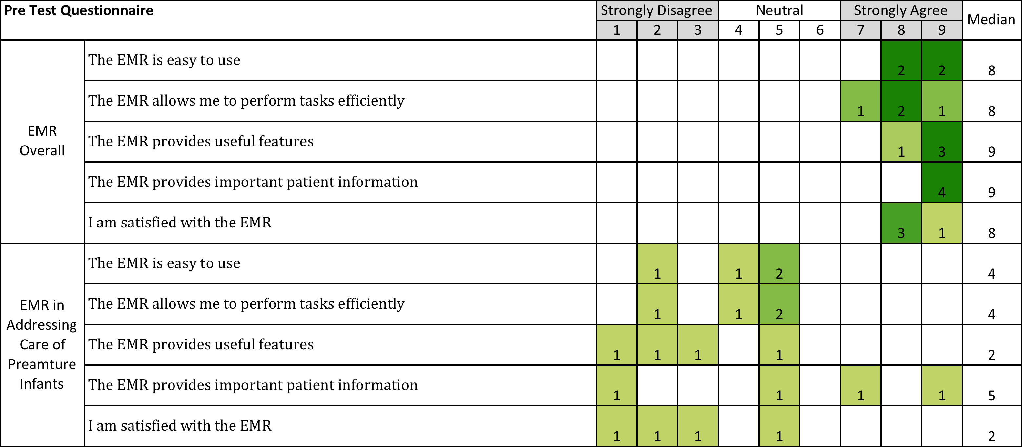

Discussion:
Responses to the pre-test questionnaire show a contrast in physicians rating of the EMR in general vs. rating the EMR in specifically supporting the care of premature infants. Similar results were discovered early in our requirements phase via a use case validation where physicians rated a low level of satisfaction with the EMR to support premature infant care.

Summary of Task Based Scenarios and Post-Test Questionnaire Results:
Participants attempted 8 task-based scenarios using the system. For each scenario the participant was observed for a set of objective measures (task completion, error rate and time on task) and after each scenario was given a brief post scenario questionnaire (see Appendix A and B). After completing the eight scenarios participants completed a Post-Test Questionnaire where they rated the system overall and answered a number of open-ended questions (see Appendix C).

Table 2: Scenario and Post Test Rating Question Results
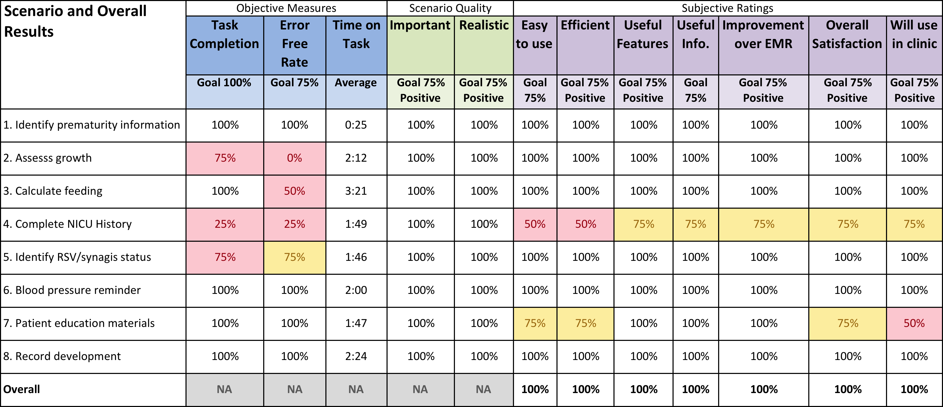

Red highlighting represents a metric below target.
Yellow highlighting represents a metric at target threshold.
No highlighting represents target achieved.

Post Test Questionnaire Open Ended Responses:

What, if anything, did you like least about the system
Confusion over growth charts
Printing patient education materials
Nothing (2 subjects)

What, if anything, did you like most about the system
Easy to navigate
Information all on one page
Highlights important issues routinely addressed
Organized and accessible

What, if anything was missing from the system
Features to make NICU History complete
Add consults
Consults in one space
Information on nutritional supplements

If you could have this system do anything you wanted, what would that be (wild ideas welcome):
Development resources
Specialty appointment information
Related issues meds equipment (monitors, feeding tubes)
Automatically complete HX from direct transfer of information from hospital to chart
More information on specialty care
Overview of preemie care - neonatal follow up - as in the old otitis assistant with guidelines
Consult summary - cardiology, eye, hearing, development…

Discussion and Recommendations:
Of the eight task based scenarios the system failed to achieve the objective measure targets in 4 scenarios and failed to achieve the subjective measure targets in 2 scenarios. The system did achieve all subjective measure targets overall (post-test questionnaire) at 100% for each attribute ranked.

Errors contributing to the failure of objective measures were consistent and suggested low cost user interface design fixes with relatively low effort. The remainder of this report details the findings of each of the eight task-based scenarios and provides a discussion of the observations and results. Where the system failed to meet test targets, design recommendations are included. The overall recommendation from the test are to implement these design changes and re-test the impacted task based scenarios with a small set of new participants.

Scenario 1: Identify prematurity Information
Scenario 1 was largely a “warm up” scenario to help participants understand the format of the test. While this scenario highlighted a feature of the system, no issues or difficulties were expected.

“You are in an office visit with a patient who is a premature infant under the age of two. Identify the patient’s chronological age, corrected age, gestational age and birth weight.”

The scenario focused on having the participant identify the header of the application that lists 4 pieces of information about the patient specifically relating to their prematurity.

- Chronological Age (The actual age of the patient from birth)
- Corrected Age (The patient’s age adjusted for their prematurity)
- Gestational Age:
- Birth Weight:

Figure 1: Preemie Assistant Header

Objective Results:
- Task Completion = 100%
- Error Free = 100%
- Time on Task = Average 0:25

Table 3: Scenario 1 Questionnaire Results
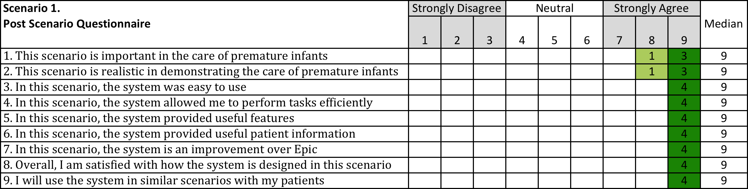

Participant Comments:
“This is very nice”
“ I am curious how you round for weeks and months.”
“Very convenient.”

Discussion and Recommendations:
Having this information more visible was a useful feature of the Preemie Assistant. Corrected Age is not something the EMR provides and must be calculated manually by the clinician as they interact with the patient and EMR. Having the system provide this calculation and the other information was commented on as being very valuable and convenient.

This scenario achieved all targets with no issues or errors. There are no changes recommended.

Scenario 2: Growth Status and Details
This scenario was designed to test the Preemie Assistant growth alert function as well as the provided growth assessment table in the “Growth and Nutrition Calculator.”

“Identify the patient’s overall growth status and details on the patient’s growth history and measurements.”

The objective of the scenario was to have the participant recognize the low growth alert as presented in the Preemie Assistant, then access the Growth and Nutrition Calculator that provided a detailed growth assessment in a table format. The system also provides links to the EMR growth chart feature and automatically preselects the correct chart, World Health Organization (WHO) growth charts, but the system is incapable of auto-selecting a checkbox in the EMR that adjusts the growth charts for corrected age.

Objective Results:
- Task Completion = 75%
- Error Free = 0%
- Time on Task = Average 2:12

Table 4: Scenario 2 Questionnaire Results
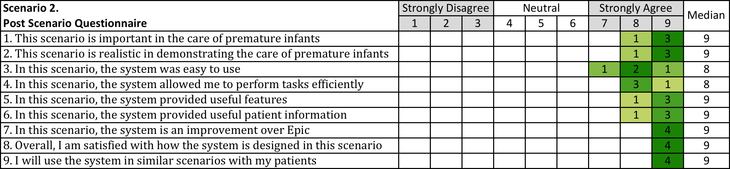

Participant Comments:
“I’m a picture person and I want the quickest answer.”
“You don’t need to tell me no cereals, who are you telling this to? The parent?”
“This (growth data table) needs to be in English (measures) so I can talk to the parents about it.”
“I compare growth velocity over a few days to see if my new recommendation is working and this will help with that. “

Discussion and Recommendations:
Scenario 2 is interesting and unique in that the errors were actually encountered in the EMR and not in the Preemie Assistant. While the Preemie Assistant growth table displayed the correct analysis of patient growth, participants went on to open the EMR growth chart and due to design issues of the EMR committed the following two errors. First, although it is the organizational policy of the care network to use the EMR World Health Organization (WHO) growth charts for premature infants and the EMR has been configured to automatically load these charts, some participants switched from the WHO chart to the Center for Disease and Control (CDC) Premature Infant growth chart also provided by the EMR. Both the CDC and WHO state the CDC chart is obsolete. Second, in using the WHO growth chart, participants failed to recognize and then select a check box that would automatically adjust the WHO chart for the patient’s corrected age.

While technically demonstrating design errors of the EMR, in order to be successful the system must support using the correct tools in the analysis of growth. The ideal solution to address these errors is for the EMR vendor to redesign or configure their system to:

- Load automatically the correct chart for premature infants.
- Automatically recognize premature infants and adjust the growth chart for corrected age.
- No longer provide access to charts such as the CDC premature growth chart (CDC and WHO both have published information that this chart is no longer valid).

Since EMR re-design is unlikely to occur in a timely fashion, recommendations to address these errors include:

- Re-label growth table with short informative text on WHO charts
- Consider removing growth chart links from growth table section
- Explore options for care network to remove CDC chart from EMR

Figure 2: Preemie Assistant Growth Table

Figure 3: EMR WHO Growth Chart with Age Correction Unchecked
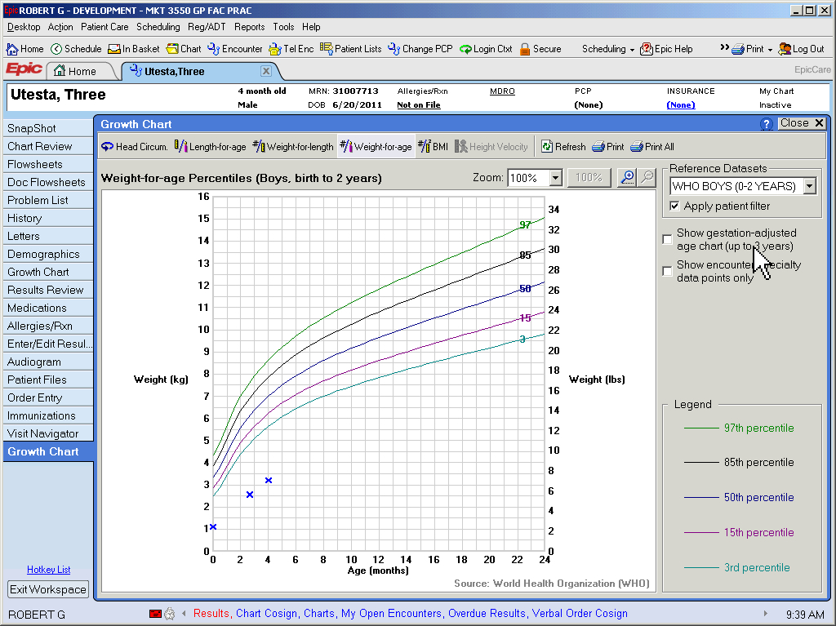
Figure 4: EMR WHO Growth Chart with Age Correction Checked
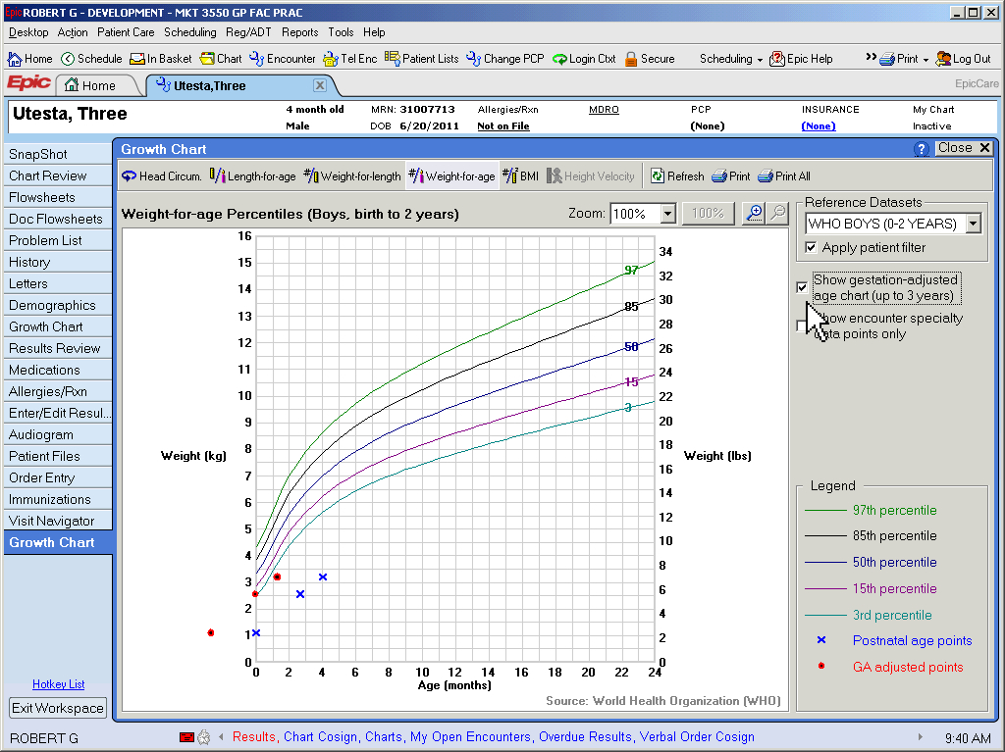

Figure 5: Pull Down Showing Other EMR Growth Charts
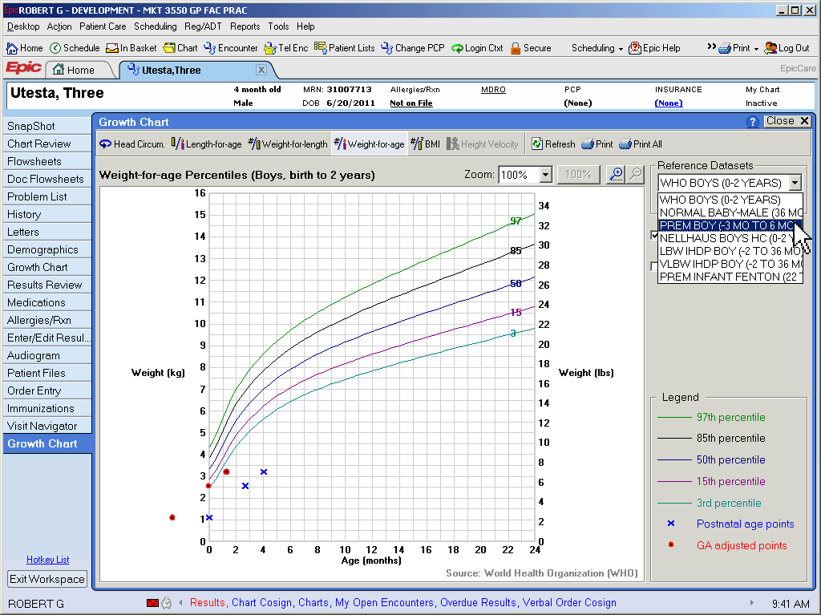

Figure 6: Outdated CDC Premature Growth Chart Provided by the EMR
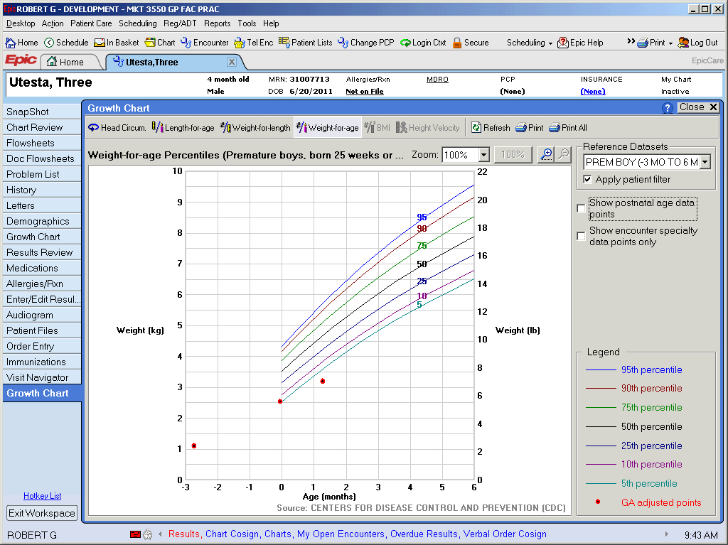

Scenario 3: Calculate New Feeding Recommendation
This scenario was designed to test the Preemie Assistant Nutrition Calculator feature designed to assist physicians in producing feeding recommendations for patients with inadequate growth.

“Continuing from Scenario 2, you wish to create a new feeding recommendation in order to address the child’s low weight.

Please note. The parent tells you the child is currently feeding with:
Elecare at 22 calories per oz.
2 oz. per feeding
8 feedings per day

They also note the child takes a long time to feed. Explore both increasing the amount of feeding and the caloric density with a preference for increasing caloric density. Use the system to provide the parent with instruction on how to mix the formula to the new caloric density.”

The objective of the scenario was to have the participant recognize and use the Preemie Assistant Nutrition Calculator to enter information about the current feeding, then make adjustments to produce a new feeding recommendation. With the new feeding recommendation requiring an increase in formula caloric density, the participant would then utilize the systems functionality to automatically retrieve and print new formula mixing instructions for the parent.”

Objective Results:
- Task Completion = 100%
- Error Free = 75%
- Time on Task = Average 3:21

Table 5: Scenario 3 Questionnaire Results
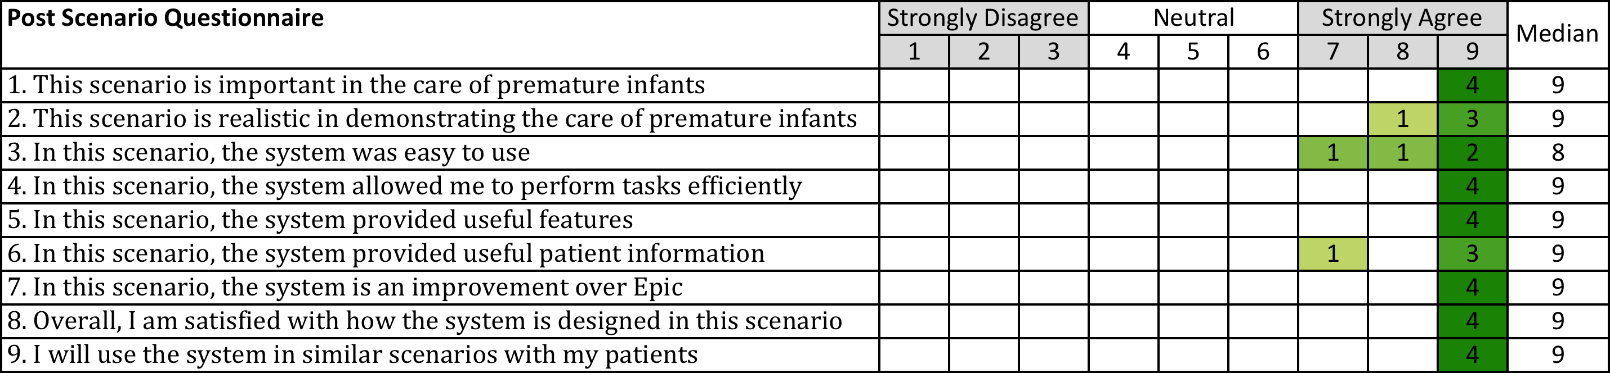

Participant Comments:
This is my favorite.
This will save time.
I will use this to explore options I would not normally do.

Discussion and Recommendations:
The error resulting in the Error Free Rate of 75% was a non-critical error that the participant recovered from. It resulted from not recognizing labeling and therefore suggests a superficial visual fix. In addition, while not an error, all participants were observed having some difficulty with the formula pull down menu. This suggests the list could be better organized by sorting in alphabetical order (see Figure 8).

Though it did not contribute to any errors, participants expressed some confusion about the checkboxes for various feeding problems (see Figure 7). They expected that selecting these items would have some impact on the calculator, but were not certain how this would occur. In fact, the check boxes do not have any impact on the calculations. Early designs included factoring in feeding problems, but it was soon realized this was far too complex and no firm calculation could be made. It was decided to retain the check boxes as a sort of “reminder” for physicians to consider these issues in assessing growth and nutrition.

While not contributing to an error the disabled state of the mixing instruction buttons for Spanish could be revised to save one extra click by having the Spanish radio button show as disabled when a Spanish document was unavailable.

Recommendations:
- Re-label nutrition calculator “Current,” New,” and totals more clearly.
- Arrange items in pull down in alphabetical order.
- Consider removing check boxes completely or simply list these items as non -selectable feeding problems to consider.
- Reconfigure Spanish radio button to show as disabled when no Spanish version of the mixing instructions is available.

Figure 7: Nutrition Calculator with Check Boxes
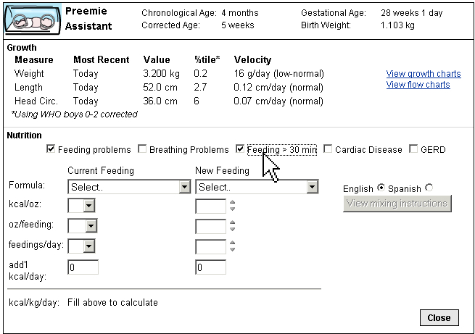

Figure 8: Formula Pull Down List
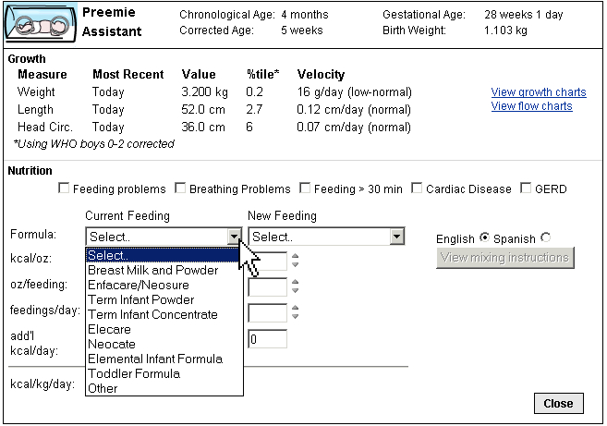

Scenario 4: NICU History Documentation
This scenario was designed to test the Preemie Assistant NICU History feature designed to assist physicians in documenting a consistent and thorough patient history.

“You have a copy of the patient’s NICU discharge summary (not from our hospital). Abstract this document into the EMR so that any important NICU related information so that other clinicians, inpatient or outpatient, would be able to easily locate this information.”

The objective of the scenario was to have the participant recognize the NICU History alert and provided EMR “Smart Phrase” or documentation template and to use it not in a progress note, but in the EMR birth history section. In order to complete the task participants would follow the link to the birth history section and trigger the Smart Phrase in the Birth History comment section.

Objective Results:
- Task Completion = 25%
- Error Free = 25%
- Time on Task = Average 1:49

Table 6: Scenario 4 Questionnaire Results
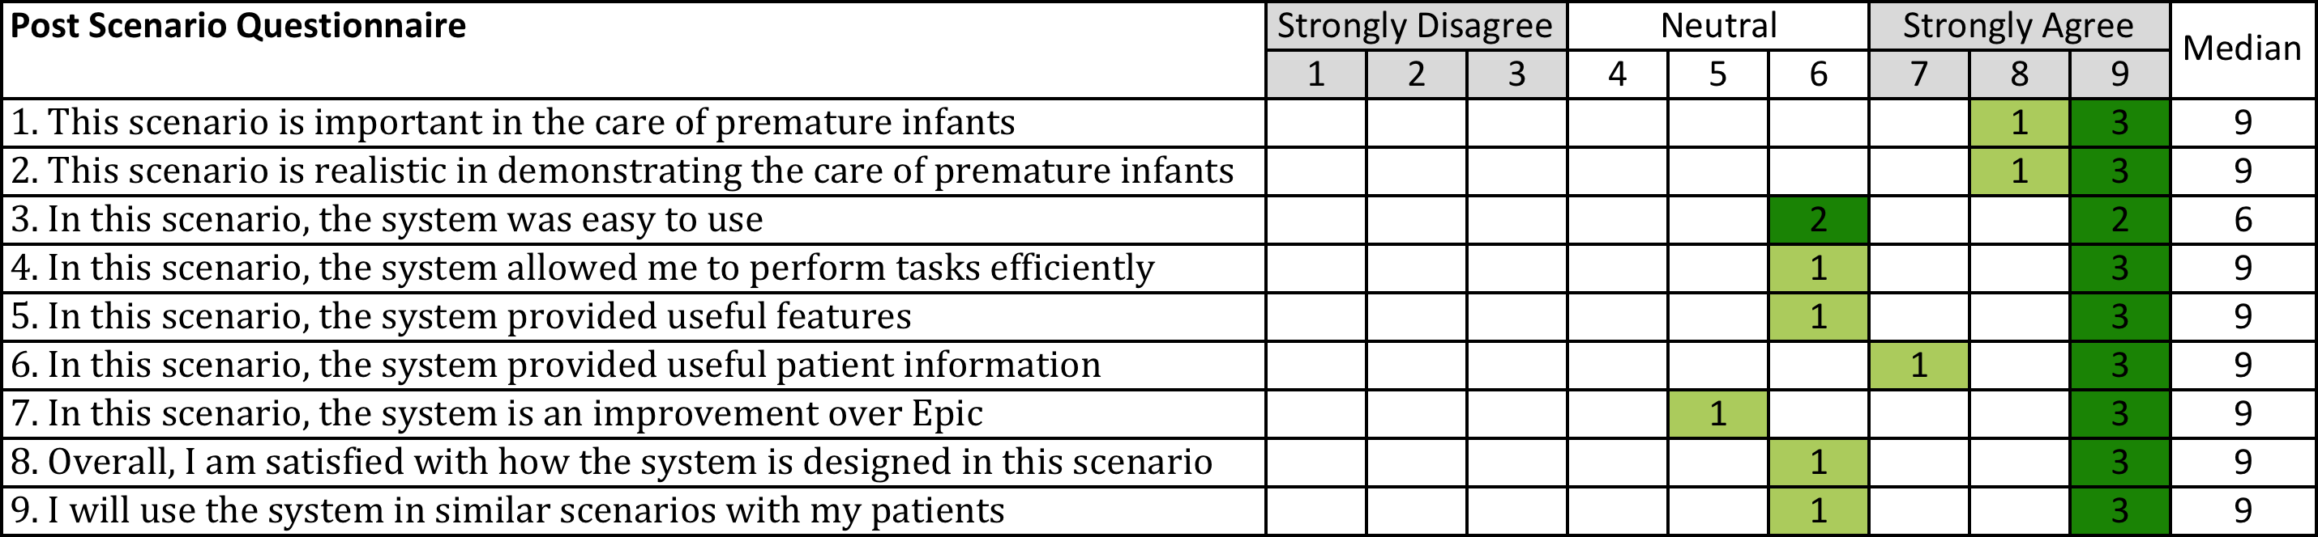

Participant Comments:
“Again, I didn’t read.”
“Not my favorite, but I like the Smart Phrase.”
“It could have information on the mother.”
“The Smart Phrase is much more thorough than what is currently done.”

Discussion and Recommendations:
The primary error in this scenario was that participants did not recognize the text describing the Smart Phrase and as a result documented the NICU History manually or with other templates. Participants who did not use the provided Smart Phrase would have produced adequate and highly detailed NICU History documentation, but since the system failed to notify them clearly on the new documentation resource we considered this a task failure of the system. After the scenario the participants were given a demonstration of the new Smart Phrase and it received favorable comments.

This functionality is not critical to patient outcomes and is meant to provide more of a convenience. As a result only low effort changes are recommended:

- Include in link text the name of then Smart Phrase
- Reduce excessive synonyms of the Smart Phrase in the EMR
- Proceed with plans to have a “Smart Tool” section/page included in the Preemie Assistant

Figure 9: Summary Screen Showing Incomplete NICU History

Figure 10: EMR Birth History Screen with Smart Phrase Being Selected
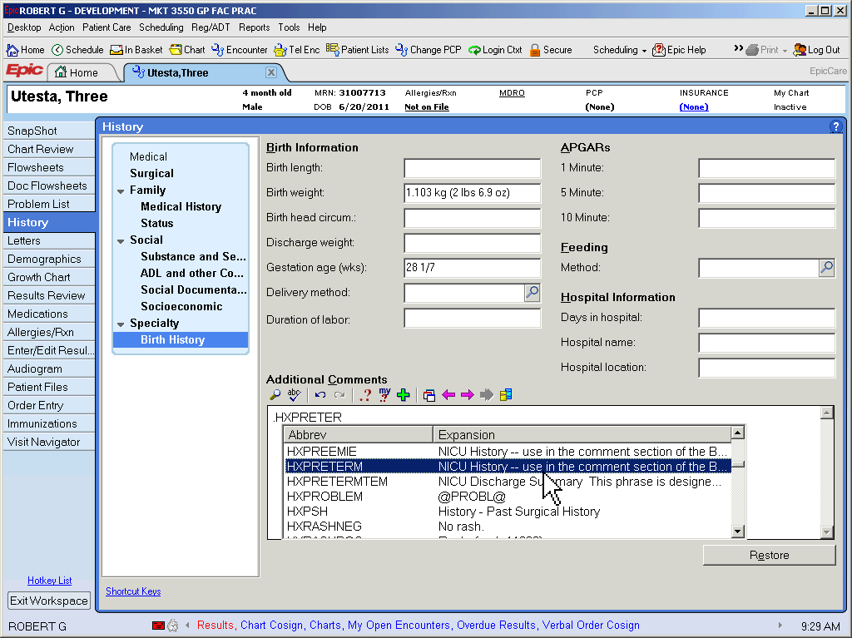

Figure 11: Summary Screen Showing Completed NICU History
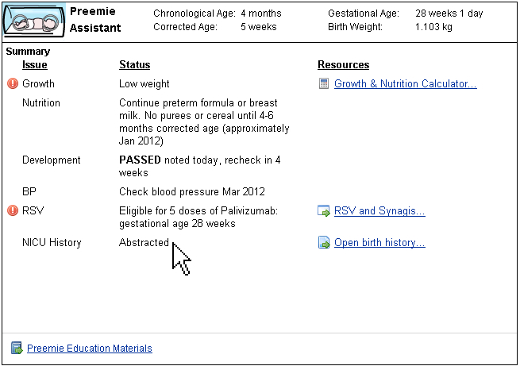

Scenario 5: RSV and Synagis Status
This scenario was designed to test the Preemie Assistant RSV Assistant in notifying the physician of patient status of eligibility, insurance coverage and dose scheduling.

“In early September you asked your nurse to submit this patient for approval for Synagis. Unfortunately the nurse is not in today and the parent has asked you if they have been approved. Please ascertain the patient’s approval status for Synagis.”

The objective of the scenario was to have the participant recognize the RSV status and access the RSV assistant to ascertain the status.

Objective Results:
- Task Completion = 75%
- Error Free =75%
- Time on Task = Average 1:46

Table 7: Scenario 5 Questionnaire Results
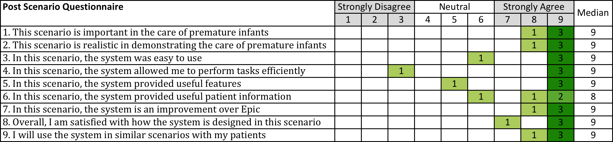

Participant Comments:
“There is a lot of information here, but I only need a summary.”
“It should tell us up front (Summary) if they are approved or next dose. “
“Eligible” isn’t useful here.”

Discussion and Recommendations:
The primary issue in this scenario was that the Summary page and RSV status should contain more explicit messages on status thereby preventing the need for the physician to use the RSV assistant at all. Note, in one case the physician began adjusting form fields in the RSV assistant, which could have disrupted the nurse’s efforts and work to date. This confirms earlier design work where nurses, in effect, asked that physicians be limited in some way from accessing tools dedicated to nursing.

Recommendations:
- Utilize more clear and specific RSV status messages including a set of messages for the approval process and once approved a set of messages based on dose scheduling.
- Consider removing access to the RSV Assistant to physicians.
- Consider, if possible, providing instead a link to the RSV Patient List which is much more useful and communicative resource for nurse – physician interaction on RSV and Synagis.
Figure 12: Summary Screen Showing RSV Status Message
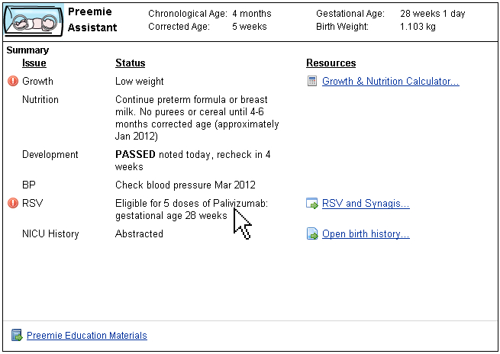

Figure 13: RSV Assistant Showing Patient is Approved
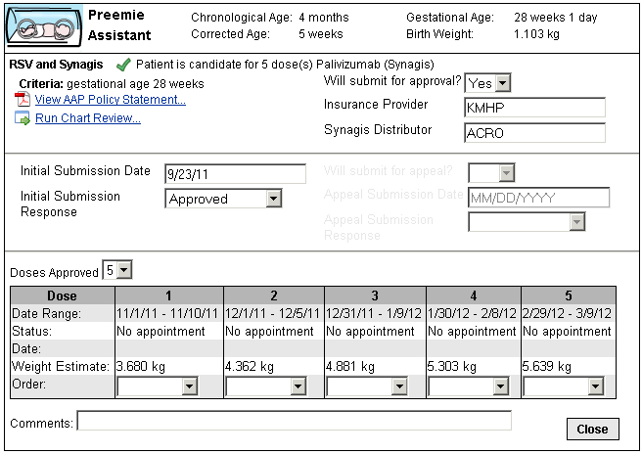

Scenario 6: Blood Pressure Reminder
This scenario was designed to test the Preemie Assistant blood pressure alert features.

“Assess any issues or recommendations regarding the patient’s blood pressure. Then record in Epic a blood pressure of 115/75.”

The objective of the scenario was to have the participant recognize the blood pressure check reminder then recognize and respond to the system messages/status when a high blood pressure was recorded.

Objective Results:
- Task Completion = 100%
- Error Free =100%
- Time on Task = Average 2:00

Table 8: Scenario 6 Questionnaire Results
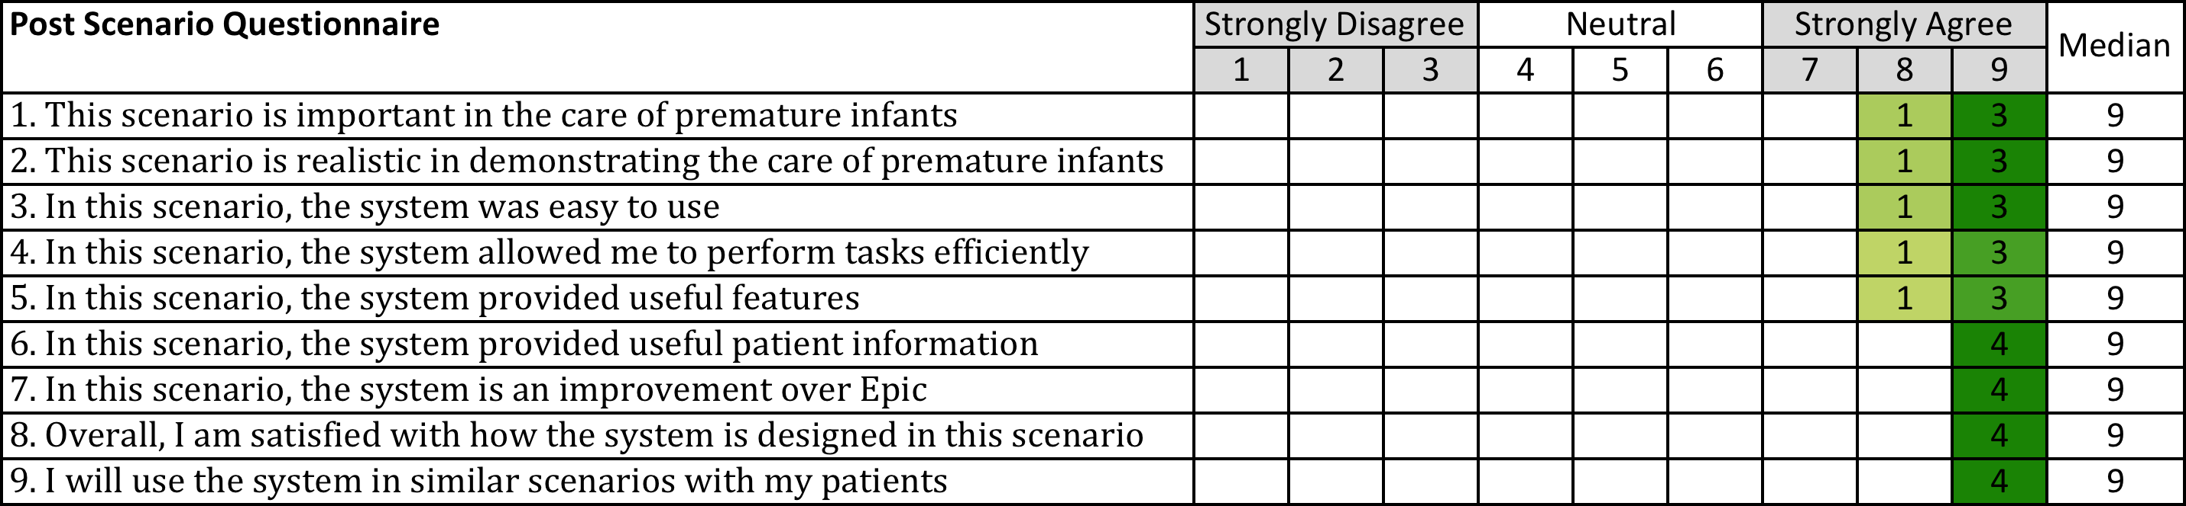

Participant Comments:
“It’s good that it reminds us on BP.”
“We need CME (continuing medical education) on preemies.”

Discussion and Recommendations:
Testing in this scenario produced no errors or issues. Participants rated the system highly on all attributes. In addition, during the beta release of the Preemie Assistant this alert feature was recognized by physicians and helped identify two infants in a hypertensive crisis. No changes or recommendations are required.

Scenario 7: Patient Education Materials
This scenario was designed to test the Preemie Assistant in providing age based patient education content.

“A parent has many questions about caring for their premature infant. You wish to provide them with educational materials to help them. Provide any and all patient education materials relevant to their child. When finished, repeat for the younger patient used in scenarios 1-5.”

The objective of the scenario was to have the participant recognize the patient education link and then access the provided content. In addition, the participant would recognize that the education content provided was automatically targeted to the patient by age.

Objective Results:
- Task Completion = 100%
- Error Free =100%
- Time on Task = Average 1:47

Table 9: Scenario 8 Questionnaire Results
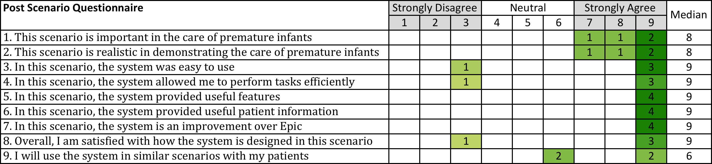

Participant Comments:
“Oh this is nice. “
“This is awesome.”
“Who the heck knew we even have all this?” (Education materials)
“I have never given out one of these.”
“Patient education is the most important thing we do. In 15 minutes there isn’t time to cover everything.”
“Too hard to print. You need checkboxes so I can print all at once.”
“I need to print this all together – other people are printing too and we need to keep it all together.”

Discussion and Recommendations:
This scenario produced 100% task completion and no errors and overall appreciation for assistance in patient education was high. However, comments and the lower satisfaction ratings indicated issues with the systems present level of effort in selecting and printing documents one at a time. Fortunately this suggests a simple and clear fix by providing interaction elements that allow for printing any or all documents at once.

Recommendation:
- Provide the ability to multi select any or all documents and then print the selected from a single click or button.

Figure 14: Patient Education Materials for Patient with Corrected Age of 5 Weeks
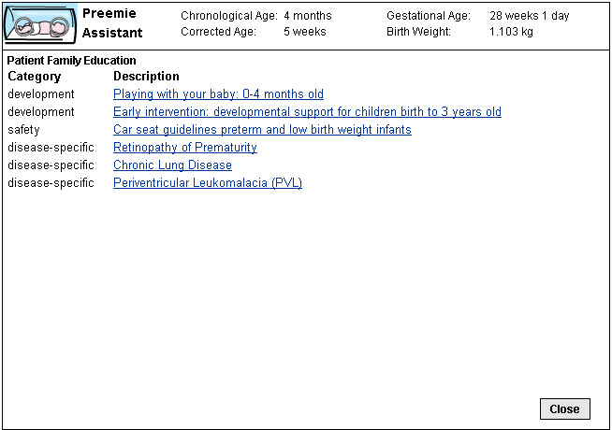

Figure 15: Patient Education Materials for Patient with Corrected Age of 7 Months
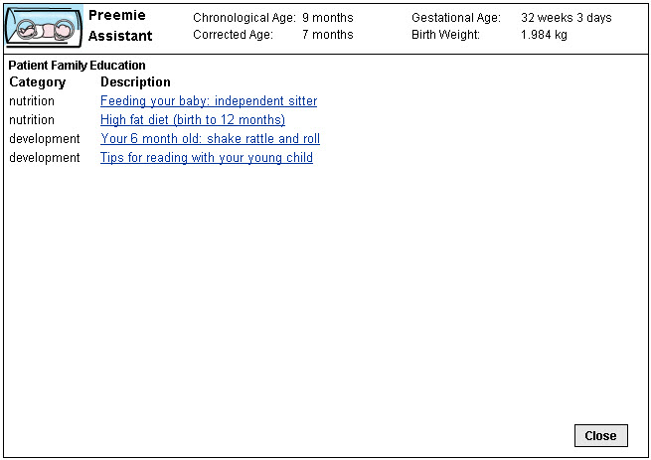

Scenario 8: Development
This scenario was designed to test the Preemie Assistant in providing automatically age corrected development assessment questions in the EMR provided Well Child “Smart Phrase” or documentation template.

“A parent has many questions about caring for their premature infant. You wish to provide them with educational materials to help them. Provide patient education materials relevant to their child’s age. When finished, repeat for the younger patient used in scenarios 1-5.”

The objective of the scenario was to have the participant use the age corrected Smart Phrase. This is an automated feature of the Preemie Assistant, so while no errors were expected the scenario was included to collect feedback on the feature.

Objective Results:
- Task Completion = 100%
- Error Free =100%
- Time on Task = Average 2:24

Table 10: Scenario 8 Questionnaire Results
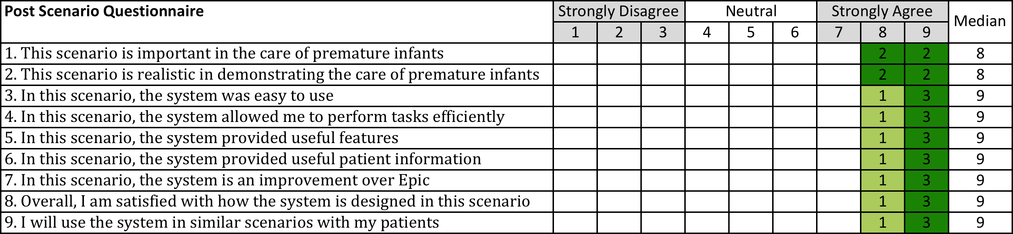

Participant Comments:
“I don’t like the development questions we use.” (standard questions in the EMR)
“I start with the chronological age questions, then back track to the corrected. Sometimes there is scattering.”
“I already delete the questions and add the correct ones. “
“For the first visit, newborn visit, the smart set development questions are always wrong and uncorrected.”

Discussion and Recommendations:
With 100% task completion, no errors and high subjective ratings there are no changes recommended for this scenario. While the participants in the test seemed aware of the issue in needing to correct the development questions in the Smart Phrase, previous analysis showed that developmental assessments were often uncorrected in the EMR, so this feature should remain in place.

Additional Findings

Interaction Issues
Throughout the test and across scenarios participants were observed encountering minor difficulties with the system. First, the “container” of the Preemie Assistant often required vertical scrolling to keep the application visible and centered on the available screen space. Second, it cannot be stressed how rapid and quickly physicians interacted with the EMR. They seem to have well established routines with the EMR screens and functions and rarely pause to read all text – descriptive, alert or otherwise.

Overall recommendations:

- Reduce the vertical size of the Preemie Assistant to avoid the need to scroll and reposition the application in the EMR screen.
- While the Preemie Assistant demonstrates an economical approach to text, every instance of alert and descriptive text should be revisited and, if possible, be reduced to the most succinct message possible.

Functionality

During the Post Test Questionnaire participants commented on a number of additional features/functions that would be valuable in the care of premature infants. One topic of interest was to have functionality supporting specialty care information or care coordination. This is of particular interest since early design work of the Preemie Assistant included these types of features and information (see Figure 16). While it is difficult if not impossible to provide specialty information outside of the care network, any updates or modifications to the Preemie Assistant should explore ways to include specialty care information in some type of summary presentation.

Figure 16: Early Design Mockup Showing Care Coordination Summary
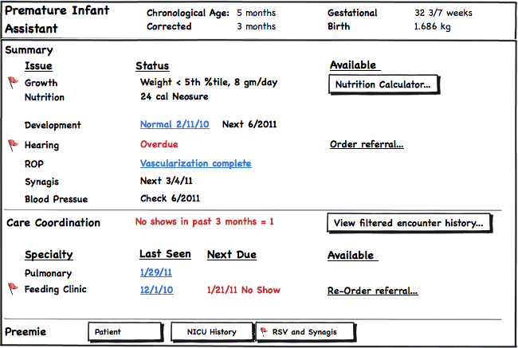

Appendix A: Pre-Test Questionnaire

Pre1. I have been in practice for ___ years.

Pre2. I have been using the EMR for ____ years.

Rate the following | Strongly Disagree |  |  | Neutral |  |  | Strongly Agree
 | 1 | 2 | 3 | 4 | 5 | 6 | 7 | 8 | 9
Pre3. Overall, Epic is easy to use
Pre4. Overall, Epic allows me to perform tasks efficiently

Pre5. Overall, Epic provides useful features
Pre6. Overall, Epic provides important patient information
Pre7. Overall, I am satisfied with Epic
Pre8. In addressing the care of premature infants, Epic is easy to use
Pre9. In addressing the care of premature infants, Epic allows me to perform tasks efficiently
Pre10. In addressing the care of premature infants, Epic provides useful features
Pre11. In addressing the care of premature infants, Epic provides important patient information
Pre12. Overall, I am satisfied with how Epic is designed to address the care of premature infants

Appendix B: Post-Scenario Questionnaire

Scenario #
Description of scenario to participant listed here

Rate the following, based on this scenario | Strongly Disagree |  |  | Neutral |  |  | Strongly Agree
 | 1 | 2 | 3 | 4 | 5 | 6 | 7 | 8 | 9
1. This scenario is important in the care of premature infants
2. This scenario is realistic in demonstrating the care of premature infants
3. In this scenario, the system was easy to use
4. In this scenario, the system allowed me to perform tasks efficiently
5. In this scenario, the system provided useful features
6. In this scenario, the system provided useful patient information
7. In this scenario, the system is an improvement over Epic
8. Overall, I am satisfied with how the system is designed in this scenario
9. I will use the system in similar scenarios with my patients

10. Additional comments, if any:

Appendix C: Post-Test Questionnaire

Rate the following | Strongly Disagree |  |  | Neutral |  |  | Strongly Agree
 | 1 | 2 | 3 | 4 | 5 | 6 | 7 | 8 | 9
PT1. Overall, the system was easy to use
PT2. Overall, the system allowed me to perform tasks efficiently
PT3. Overall, the system provided useful features
PT4. Overall, the system provided useful patient information
PT5. Overall, the system presents an improvement over the standard EMR workflow in caring for premature infants
PT6. I will use this system when I see premature infants
PT7. Overall, I am satisfied with how the system is designed to address the care or premature infants

Open ended questions:

PT8. What, if anything, did you like least about the system

PT9. What, if anything, did you like most about the system

PT10. What, if anything, was missing from the system

PT11. If you could have this system do anything you wanted, what would that be (wild ideas welcome):

PT12. Additional comments, if any:

