4th International Conference on Applications of Neuroimaging to Alcoholism
ICANA-4

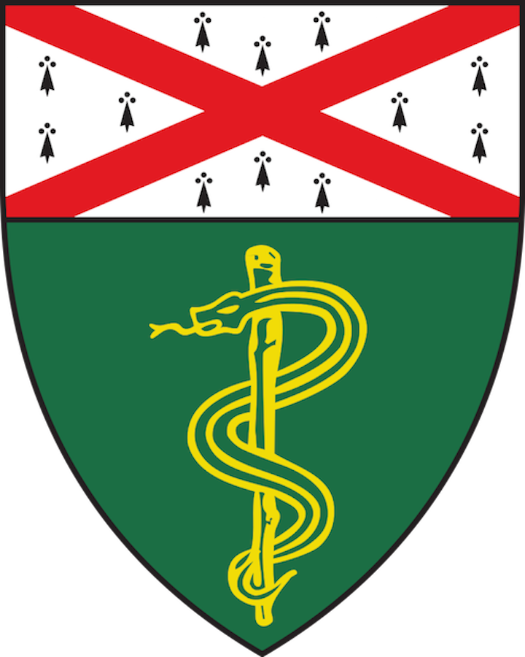

July 19-21, 2019
Yale School of Medicine

The Anlyan Center (TAC)
300 Cedar Street, New Haven, CT

Sponsored by:

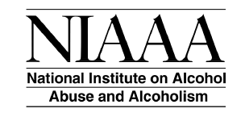

With additional support from:

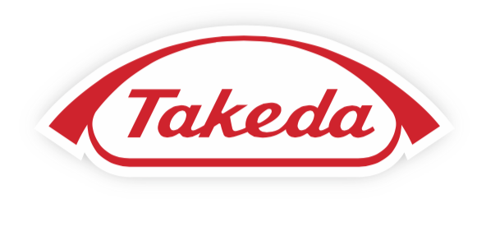

ICANA-4 Agenda

Friday, July 19, 2019
9:00am to 9:45am |  | Registration/Continental Breakfast (TAC Upper Level Lobby)
10:00am to 10:15am |  | Welcome (CMHC)
 |  | John Krystal, CTNA Director, ICANA-4 Chair
 |  | Yale Department of Psychiatry Chair
10:15am to 11:30am |  | Plenary Lecture: "Neurobiology of Alcohol Use Disorder:
 |  | A heuristic framework for future research"
 |  | George F. Koob, NIAAA Director
12:00pm to 1:15pm |  | Lunch (TAC)
1:15pm to 3:30pm |  | Session I: Stress and Craving of Alcoholism
 |  | Rajita Sinha & Hedy Kober, Yale University (Chairs)
 |  | Mauricio Delgado, Rutgers
 |  | Colleen Hanlon, MUSC
 |  | Howard Becker, MUSC
 |  | Hedy Kober, Yale University
3:30pm to 3:45pm |  | Break
3:45pm to 6:00pm |  | Session II: Inflammation of Alcoholism
 |  | Stephanie O'Malley & Kelly Cosgrove, Yale University (Chairs)
 |  | Natalie Zahr, Stanford
 |  | Ansel Hillmer, Yale University
 |  | Corinde Weirs, NIAAA Intramural
 |  | Kimberly Nixon, U Kentucky
6:15pm |  | Dinner

Saturday, July 20, 2019
7:45am to 8:45am |  | Registration/Continental Breakfast (TAC Upper Level Lobby)
8:45am to 9:00am |  | Welcome
 |  | Stephanie O'Malley, CTNA Deputy Director
 |  | Deputy Director for Clinical Research, Yale University
9:00am to 10:00am |  | Plenary Lecture: "Cognitive Control over Learning and Action
 |  | in Frontostriatal Circuits
 |  | Michael Frank, Edgar L. Marston Professor of Cognitive,
 |  | Linguistic, & Psychological Sciences
 |  | Director, Initiative for Computation in Mind and Brain, Brown U.
10:00am to 10:15am |  | Break (Upper and Lower Level Lobbies)
10:15am to 12:45pm |  | Session III: Reward and Habit Learning
 |  | Jane Taylor & Phil Corlett, Yale University (Chairs)
 |  | Alexander Genauck, Berlin
 |  | Jacqueline Barker, Drexel
 |  | Sanne DeWitt, Amsterdam
 |  | Andrew Holmes, NIH
12:45pm to 1:45pm |  | Lunch (TAC)
1:45pm to 4:15pm |  | Session IV: Structural and Functional Connectivity in Alcoholism
 |  | Godfrey Pearlson & Suchitra Krishnan-Sarin, Yale University (Chairs)
 |  | Kiliam Pohl & Adolf Pfefferbaum, Stanford
 |  | Godfrey Pearlson, Yale
 |  | Mary Heitzeg, Michigan Med
 |  | Susan Tapert, UCSD
 |  | Alecia Dager, Yale
4:15pm to 5:15pm |  | Poster Viewing Session
6:00pm to 6:30pm |  | Pre-Arranged Transportation to Yale Peabody Museum
7:00pm |  | Reception at Yale Peabody Museum

Sunday, July 21, 2019
7:30am to 8:30am |  | Continental Breakfast (TAC Upper Level Lobby)
8:30am to 8:45am |  | Welcome
 |  | John Krystal, CTNA Director, ICANA-4 Chair
 |  | Yale Dept. of Psychiatry Chair
8:45am to 9:45am |  | Plenary Lecture: "Investigating Alcohol-Induced Functional
 |  | and Longitudinal Changes in Brain Circuitry with MRI Imaging in Monkeys”
 |  | Kathleen A. Grant, Chief and Professor Oregon National Primate Research Center and Professor of Behavioral
 |  | Neuroscience, Oregon Health and Sciences University
9:45am to 10:00am |  | Poster Awards
10:00am to 10:15am |  | Break (Upper and Lower Level Lobbies)
10:15am to 12:45pm |  | Session V: Pharmacoimaging
 |  | Graeme Mason & Anissa Abi-Dargham, Yale University &
 |  | SUNY Stony Brook (Chairs)
 |  | Isabelle Bioleau, Toronto
 |  | Lawrence Kegeles, Columbia
 |  | Lorenzo Leggio, NIH
 |  | Dieter Meyerhoff, UCSF
 |  | Graeme Mason, Yale
12:45pm |  | Discussion & ICANA4 Summary
 |  | John Krystal, CTNA Director, ICANA-4 Chair
 |  | Yale Dept. of Psychiatry Chair

