YSM Office of Academic and Professional Development

YSM Request for Faculty POsition (RFP) Application
User’s Guide

Contents
Access the application 2
Application Navigation 2
List Views 3
YSM RFP Submission Process 4
Step 1: Create & Complete RFP 4
RFP Record Access 6
Step 2: Add Search Committee Members 6
Step 3: Move RFP to the Initial Departmental Review Stage 7
Step 4: Move RFP to the Initial Review – Faculty Affairs Stage 8
8
Step 5: Obtaining Conditional Approval for the RFP 9
Step 6: Add Supporting Documentation 9
Step 7: Submit RFP to Final Review – Faculty Affairs Stage 10
Step 8: Submission for Approval Workflow 10
YSM RFP Approval Process 11
Approvals History 11
Approvers: How to Approve/Reject RFP 13
RFP Approved - Disposition Statuses 15
Chatter – Record Collaboration 15
Other Tracking Activities 18
Send Email - Create New. 18
Lightning for Outlook Setup 19
Log a Call 20
Create Tasks & Assign to other Users: 20
More Reports & Dashboard Training 21
Blaze a Trail in Salesforce 21

Introduction
The Academic Faculty Search application was designed to track Request for Faculty Positions (RFP’s) through an automated approval process using the Salesforce platform. Any user who must participate in the submission or approval of an RFP must have an assigned Salesforce license. Please contact employee.services@yale.edu to request a license.

Access the application
The YSM Request for Faculty Position (RFP) application is accessible from any web browser such as Google Chrome, Microsoft Edge, and Firefox. The link can be bookmarked; accessed from the your.yale.edu website via the Work at Yale > Support > Academic Appointee Administration (AAA) Support site; or via the Academic Information worklet on the Workday home page.
- Link to the application: https://yale-hr.my.salesforce.com/

  - Users with assigned licenses will use their Yale NetID credentials to access the system when the CAS screen appears.
  - Please note, that Salesforce uses cookies for its user verification process, which means that on initial log in (per browser) users will receive a verification code which will be sent to the users’ Yale email address. Always check your junk folders.

Once successfully logged in, the Academic Faculty Search application will be open to the Home tab. (If you have access to additional applications within the HR Org, simply click the App Launcher to the left of the application name.)

Application Navigation
Navigation is located at the top of your screen and by clicking each tab at the top will navigate you to different objects and features within the application.

To learn some more about Salesforce Navigation access the following help links:
Navigate Salesforce Tabs
Get Started with Salesforce

List Views
Other than the Home page, on first click of a Tab, the List View will always default to “Recently Viewed”. To change the list view, click the down arrow next to Recently Viewed and select available list view(s).
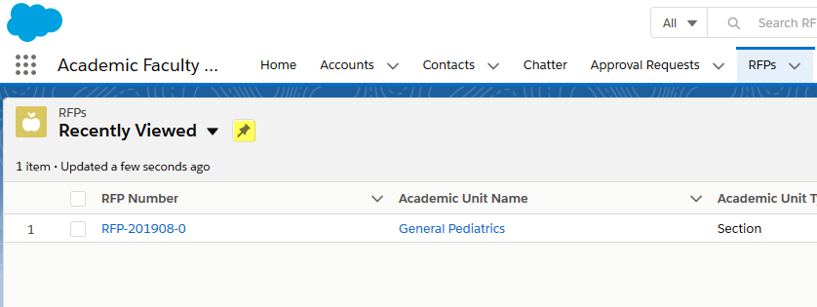
Users can create and customize their own List Views. Please review this training: https://trailhead.salesforce.com/en/content/learn/modules/lex_customization/lex_customization_list
Users can sort by each header in a list view by clicking the up or down arrow.
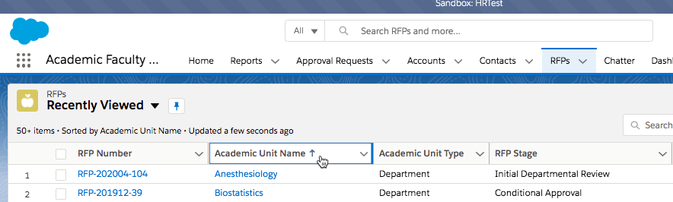

YSM RFP Submission Process
The YSM RFP Submission Process consists of RFP Stages that track where an RFP is at any point in the overall process. System validations and automatic email notifications are built into various stages of the RFP submission process.

Step 1: Create & Complete RFP
The Academic Faculty Search Process begins with the creation of an RFP. The RFP will typically be completed by the Department Faculty Affairs Coordinator/Appointment & Promotions Specialist with input from the Academic Unit’s Lead Administrator, Department Chair, and Section Chief, if applicable.
- Click on the RFP tab and click the New button on the top right side.
- The screen to enter information into a New RFP Record will appear. Note that all fields indicated with a * are required to be completed in order to save the record. The symbol next to a field indicates if there is help text, simply hover your mouse over the symbol to view. Fields with a indicate that they are a lookup field, so you will start typing the name of the Academic Unit or Lead Administrator and then click on the magnifying glass to search
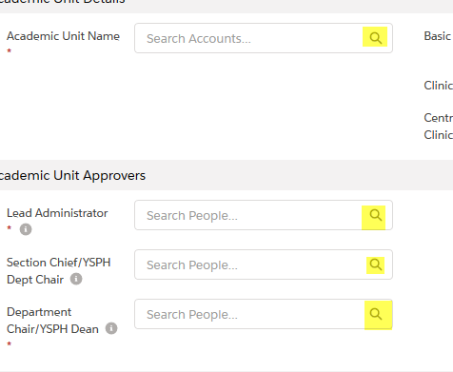
Required fields that cannot be left blank before saving the RFP are:
* Cost Center
* Academic Unit Name
* Lead Administrator
Section Chief/YSPH Dept Chair – this field is only required if the Unit Type = Section or YSPH Department
* Department Chair/YSPH Dean
* Position Type
* Reason for Position
* Expected Rank
* Expected Track
* Expected Appointment Term Start Date
* Coterminous Position?
* Clinically Active Position?
* Requesting Search Waiver?
* Targeted Appointment?

* % Research/Scholarly Activity
* % Formal Teaching
* % Clinical Service
* % Other

* Target Annual Salary
* Maximum Annual Salary

* 1st Internal Comparator Name
* 1st Internal Comparator Rank
* 1st Internal Comparator Salary

Important Note: The above fields are required and noted with the * however, based on your answers to some of the questions, the system may require more fields to be completed.
For example, if Request Search Waiver or Targeted Appointment answer is Yes, then the system will validate that the Search Waiver/Targeted Appointment Category and Justification fields are completed when the RFP is saved.
- Click the Save button once all the required fields are completed to create the record.
- If a required field is not completed, the system will display an error message and required fields must be completed before saving the RFP successfully.
- Upon initially saving the RFP, the system will automatically:
- generate and assign an RFP Number (This number is used for tracking and reference only)
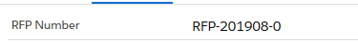
- set the RFP Stage = New
- set the Owner to be the user who created the RFP record.
- Continue to complete the rest of the RFP form as information is available.

Please reference attachment for all details on how to complete the RFP: RFP Form Map.xls
This spreadsheet identifies the fields that are required when CREATING a new RFP record for Initial Review – Faculty Affairs vs. those that are required prior to submitting the record for Final Review – Faculty Affairs.

RFP Record Access
Only the record owner and any other users that are added to the RFP record will have access to the RFP record. Access to an RFP is NOT driven by an end user’s home cost center or department. The users who will have access to the RFP are:
- RFP Owner
- RFP Owner Delegate,
- Additional RFP Delegate (this is typically the Appointments & Promotions Support Specialist who will back up the original user submitting the record),
- All Academic Unit Approvers that are added in the department approvers section of the RFP (e.g., the Lead Administrator, Section Chief/YSPH Chair),
- RFP Approvers involved in the approval workflow for an RFP
- Faculty Affairs staff

Step 2: Add Search Committee Members
RFP’s require Search Committee Members to be added prior to moving the RFP out of the New RFP Stage. The system validates that at least two (2) Search Committee members have been added to the RFP.
NOTE: If the Expected Track on the RFP is the Clinical Track or if the answer to the Requesting a Search Waiver or Targeted Appointment fields is “Yes”, then no Search Committee members are required on that RFP.
- To Add Search Committee Members, navigate to the righthand side of the screen, and locate Search Committees, click and select New.
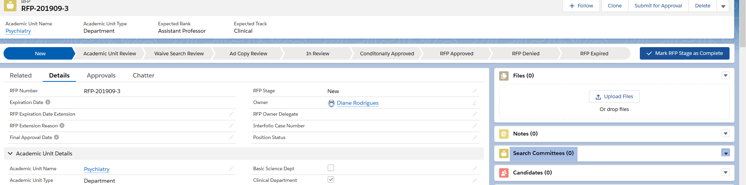
- New Search Committee box will appear, in the Name box start typing the name of the member.
- System will then display all the Workday Contact records that match what is entered, when the correct name appears click on it to enter it in the Name field.
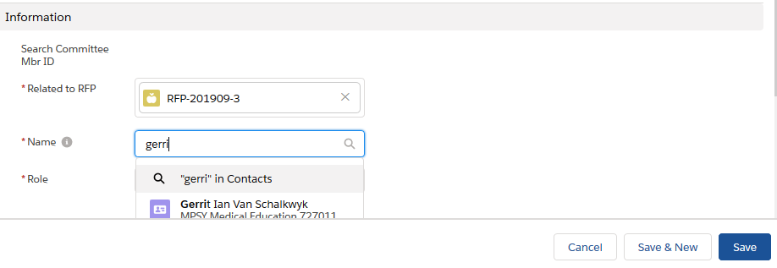
- Next Select the Member’s Role on the Search Committee.
- Click Save & New to add another Search Committee Member and repeat steps 3 and 4. Or, if no other Search Committee Members need to be added, click Save.
- The system will keep count of the number of Search Committee Members on the RFP record at the bottom under System Information.
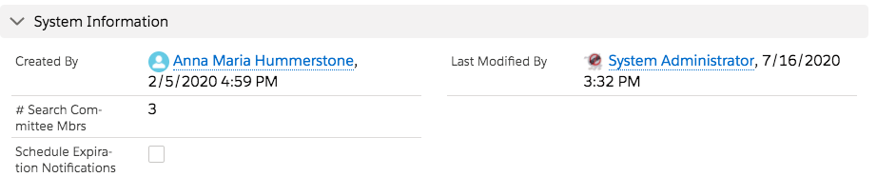

Step 3: Move RFP to the Initial Departmental Review Stage
When the RFP record is complete with all the required questions (fields) needed for the Initial Review – Faculty Affairs stage and Search Committee Members added (if needed), it can be moved to the Initial Departmental Review stage.
To move the RFP to the Initial Departmental Review Stage:
- At the top of the screen, click on the button.
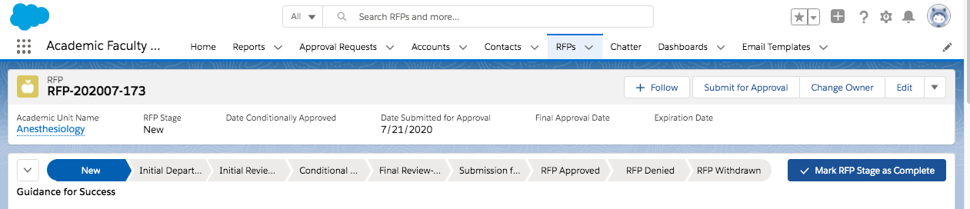
- If any required fields are missing, the system will display any error messages at the top of the screen and will NOT allow the change to the Initial Departmental Review stage.
For example, if the Search Committee Members were not added to the RFP, the error message will display after the Mark RFP Stage as Complete button is clicked.

- Correct the missing or incorrect information and Save the RFP then click the Mark RFP Stage as Complete button again.

- If there are no errors in the RFP, then a confirmation message will be displayed.
- When the RFP is successfully changed to the Initial Departmental Review stage, the system will automatically send a notification email to the Lead Administrator to determine if it is ready to be submitted for Conditional Approval.

Step 4: Move RFP to the Initial Review – Faculty Affairs Stage
When the RFP is at the Initial Departmental Review stage, the Lead Administrator will receive an email notification and will be instructed to review the RFP to determine if it is ready to submit to the Faculty Affairs Office. To do this, the Lead Administrator moves the RFP to the Initial Review – Faculty Affairs stage.
The email will include a link to the RFP that needs the Lead Administrator’s review and action.
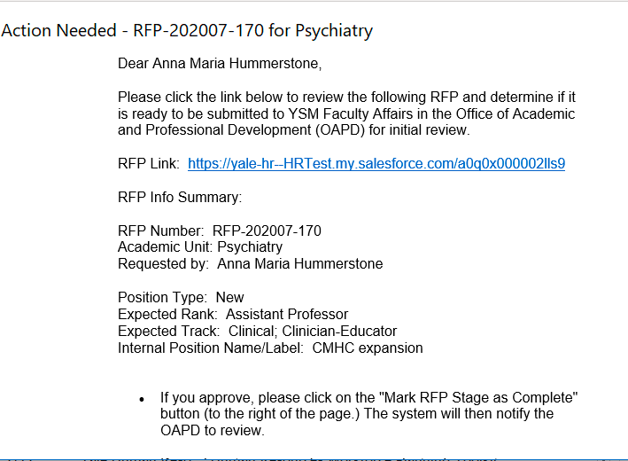
If the Lead Administrator approves of moving the RFP to the Initial Review – Faculty Affairs stage, then s/he will click the Mark RFP Stage as Complete button to move the RFP to that stage. If the Lead Administrator does NOT approve, then s/he should communicate changes to the Department Faculty Affairs/Appointment & Promotion Specialist. Once the RFP is ready to move to the Initial Review – Faculty Affairs stage, the Lead Administrator can click on the Mark RFP Stage as Complete button.
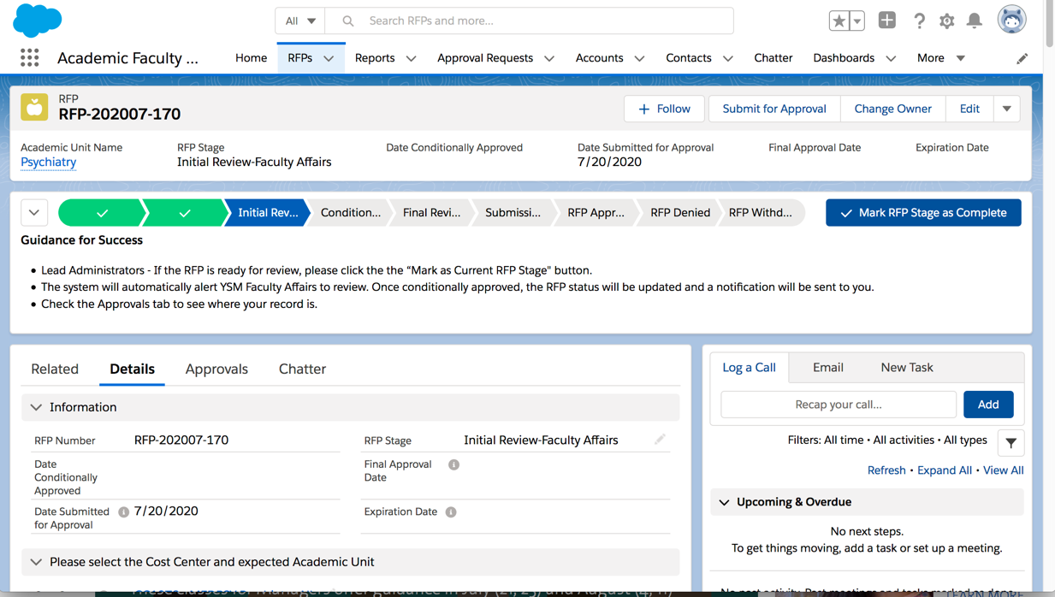

Step 5: Obtaining Conditional Approval for the RFP
When the RFP is at the Initial Review – Faculty Affairs stage, the Faculty Affairs Office staff can access the RFP and confirm that the necessary information is provided and, if appropriate, Conditional Approval can be given. The Faculty Affairs Office staff will move the RFP to the Conditional Approval stage and the RFP Owner, Owner Delegate, and Lead Administrator will automatically receive an e-mail informing them that the RFP has been Conditionally Approved.
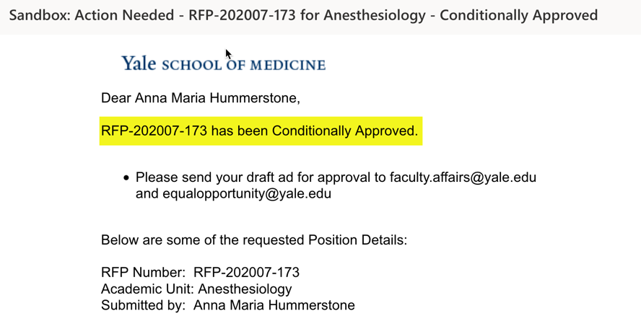

Step 6: Add Supporting Documentation
The Department Faculty Affairs Coordinator/Appointment & Promotions Specialist can add any supporting documentation to the RFP record that will need to be reviewed during the approval process. Supporting documents will be added to the Files section on the RFP found on the righthand screen of the RFP record.
IMPORTANT PROCESS NOTE: Files can be added at any stage in the RFP process even when a record has been Submitted for Approval.
- Click on next to Files and select Add Files or Click on the Upload Files.
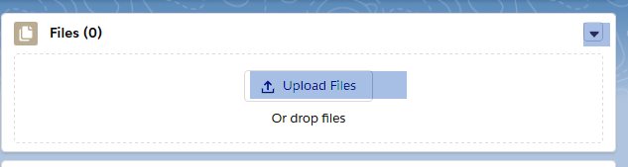
- Select the File to be uploaded and then the Done button. Note that to add additional files, the following dialog box will display showing Files already uploaded to the Salesforce system. To get to other files on your computer, click on the Upload Files button.
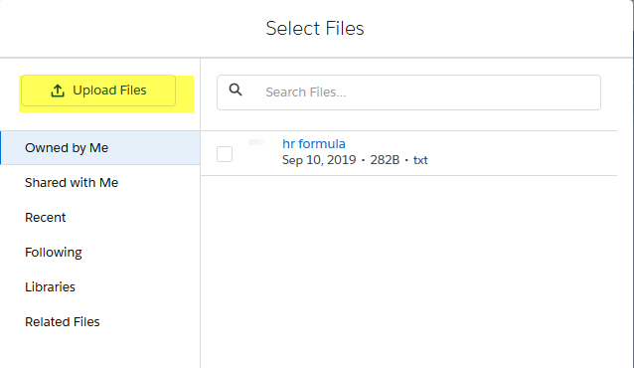

Step 7: Submit RFP to Final Review – Faculty Affairs Stage
Once all of the required fields and supporting materials/files have been added to the RFP, it is ready to move to the Final Review – Faculty Affairs stage. At this stage, the Faculty Affairs staff will confirm that the RFP is complete and, if appropriate, move the RFP to the Submission for Approval stage.
To notify Faculty Affairs that the RFP is ready for the approval workflow process, the Department Faculty Affairs Coordinator/Appointment & Promotions Specialist changes the RFP stage to Final Review – Faculty Affairs by clicking the Mark RFP Stage as Complete button.

Step 8: Submission for Approval Workflow
Only the Faculty Affairs staff can start the Approval Workflow for an RFP.
- The RFP Stage must be at the Final Review – Faculty Affairs stage to ensure that all required information has been provided.
- The Faculty Affairs staff moves the RFP to the Submission for Approval stage by clicking on the button which is located in the upper righthand side of screen. Note: This button is only available to the Faculty Affairs staff.
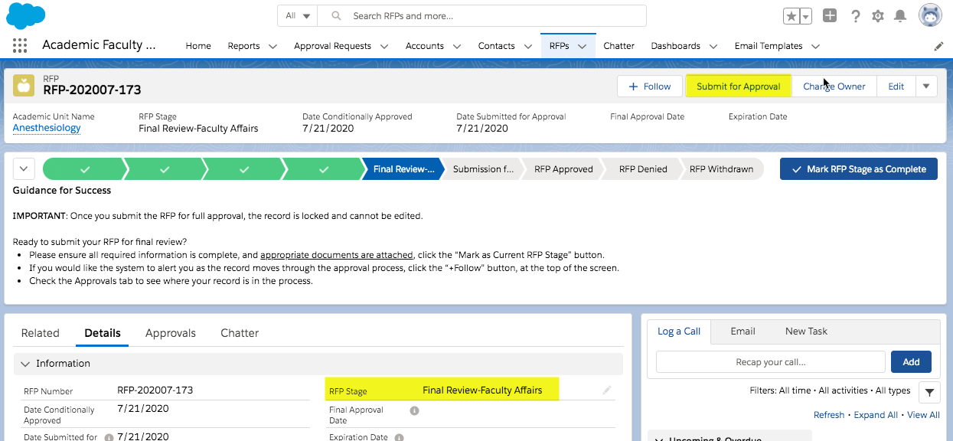
- The system will display a comments box where optional comments can be added.
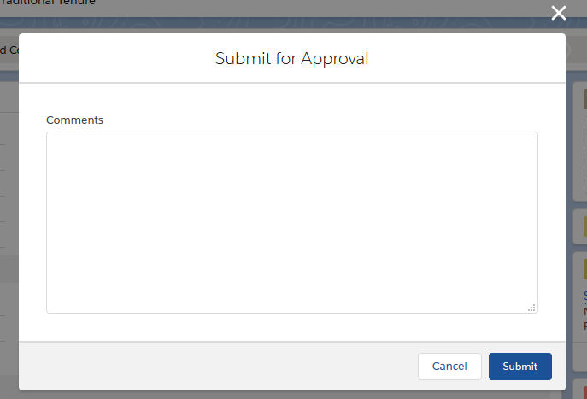
- Click the Submit button and the System will display the message “RFP Submitted for Approval”.
- The RFP Record is now locked and cannot be edited except by a System Administrator or a User who has a Pending Approval Action.

YSM RFP Approval Process
The YSM Faculty Affairs RFP Approval process is an automated process that sends the RFP to pre-assigned users and Queue members that have been identified as the approvers for a specific step.
The RFP will route to the various approvers depending on the details entered in the RFP. Please reference the RFP Approval Routing/Workflow chart below for a detailed list of the steps, criteria that sends an RFP record to the step, and the assigned Approver for each step.
It is important to understand that because the Approval process is linear the RFP record will proceed through the steps only if approved by the prior step and meets criteria for the step. If an approval step is Rejected the RFP record is then removed from the approval process and the RFP stage is automatically set to RFP Denied.
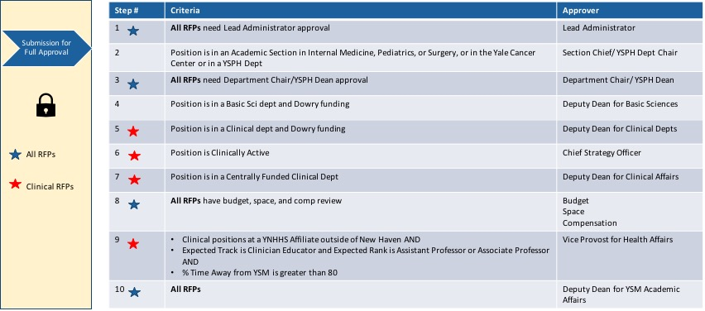

All assigned approvers will automatically receive an email notification to review and approve the RFP. The email will contain a link directly to the RFP needing approval.

Approvals History
The Approval History of the RFP can be viewed at any time from the Approvals Tab.
The Approval tab lists the History and where the Approval is in the process, it lists the Step Name, Date and Time the request was sent to the Approver, Status, and the name of the Approver or Queue who has been assigned to approve. Queues are a group of users that can be assigned at a given approval step. Within the YSM RFP approval workflow, the Budget, Space and Compensation step is assigned to a queue and all three (3) approvers must approve the RFP in order for it to move to the next approver.
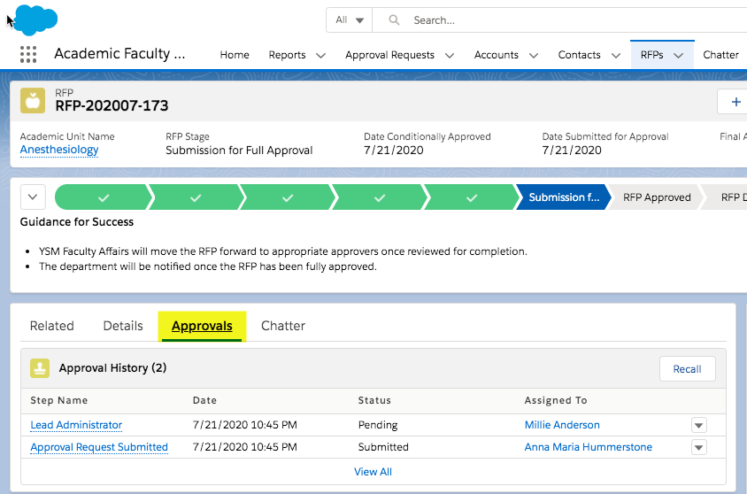
To learn more about Salesforce Approval Processes

Approvers: How to Approve/Reject RFP
- The system will send email notification to your yale.edu email address requesting approval.
- The email will contain high level details of the request. The email notification will also provide a link to the Approval record. (User will be required to log in to Salesforce if not currently logged in.)
- The approver will be brought to the RFP Details page to see the entire RFP and all related information.
- Once the RFP Details are reviewed, the Approver clicks on the Approvals tab on the RFP.
- Once the Approver has made decision on whether to approve or reject the RFP, the appropriate Approve or Reject button can be selected.
- A comments box is displayed where optional comments can be added if Approved. If Rejected, a comment must be entered.
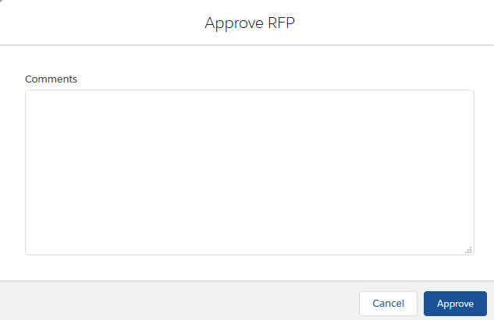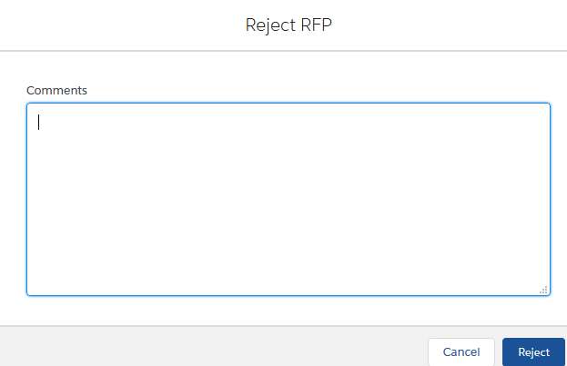
- The Approval History, with the Status, is updated in the system on the RFP Approvals tab.
- For Approvals, the system will send the RFP Approval Request email to the next user in the YSM RFP Approval Routing/Workflow.
- For Rejections, the system will send an email notification to the RFP Owner, RFP Owner Delegate, all Academic Unit Reviewers listed on the RFP, and to Faculty Affairs.
- The RFP Owner can review the Rejection comments and determine if more information is needed or if the position request is to remain rejected.
- Once the RFP is Rejected, the RFP record is unlocked and the RFP Stage is set to RFP Denied. If it is determined that the rejected RFP should be edited/updated and resubmitted for approvals, then the following steps should be taken:
  - Faculty Affairs moves the RFP back to the Conditional Approval stage.
  - The Department Faculty Affairs Coordinator/Appointment & Promotion Specialist can now access the RFP to make the necessary changes/updates.
  - The Department Faculty Affairs Coordinator/Appointment & Promotions Specialist then moves the RFP to the Final Reviews – Faculty Affairs stage.
  - Faculty Affairs can re-submit the RFP to the Submission for Approval stage.
The RFP Approvals tab will retain all the previous approval history.

RFP Approved - Disposition Statuses
Once an RFP is fully approved, the RFP stage will automatically change to RFP Approved. A Disposition Status is placed on all fully approved RFPs. This Disposition is used to track the final outcome of all fully approved RFPs.
The Disposition Statuses can only be updated by the Faculty Affairs staff. The definition and use of each status is provided in the table below:
Disposition Status | Description
ACTIVE | Default Disposition status. Used to indicate that the Search for this position is active. Automatically set by the system.
CLOSED – Filled | The Disposition status will be changed to CLOSED – Filled if a faculty member has been hired into the position.
CLOSED - Expired | The Disposition status will be changed to CLOSED – Expired if the fully approved RFP has been open for two years from the date of full approval without being filled. Automatically set by the system, but can also be set by the Faculty Affairs Coordinator.
CLOSED – In Negotiation | The CLOSED – In Negotiation status will be used on a fully approved RFP that is close to being filled and also nearing the Expiration date.
CLOSED – Canceled | The Disposition status will be changed to CLOSED – Canceled if the hiring unit decides to not proceed with filling the position prior to the two-year expiration date.

The Disposition Status is displayed on the righthand side of the RFP screen below the Search Committees section.

Chatter – Record Collaboration
All Users should review the training module here to set up profiles and get more information on how Chatter works: Get Started with Chatter – Collaboration Tool
Important Update your Email Notifications in Chatter:
- From the menu under your name, click Setup or My Settings.
- Click Chatter.
- Click Email Notifications.
- Select your preferences. For Personal digest, select Daily.
- Save your changes.
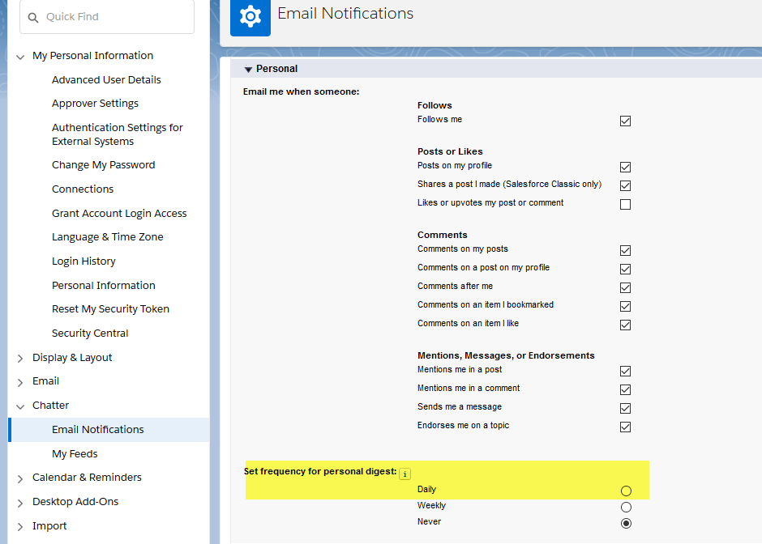

To post a chatter comment on the RFP Record, go to the Chatter tab. 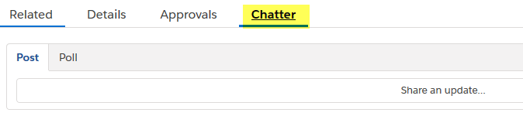
Simply type @ and the name of the user you want to be notified via email, system will find the user
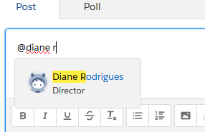

Click on the name and then type your post and click Share
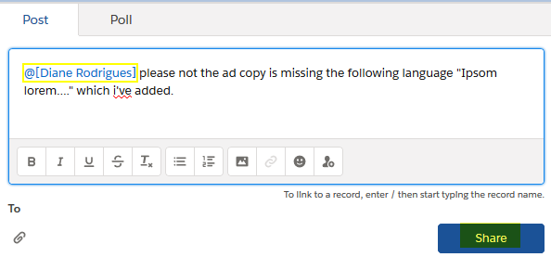

Other Tracking Activities
Users have the ability to track several types of Activities at the record Level:
- Send Email
- Log Phone Calls
- Create Tasks

Send Email - Create New.
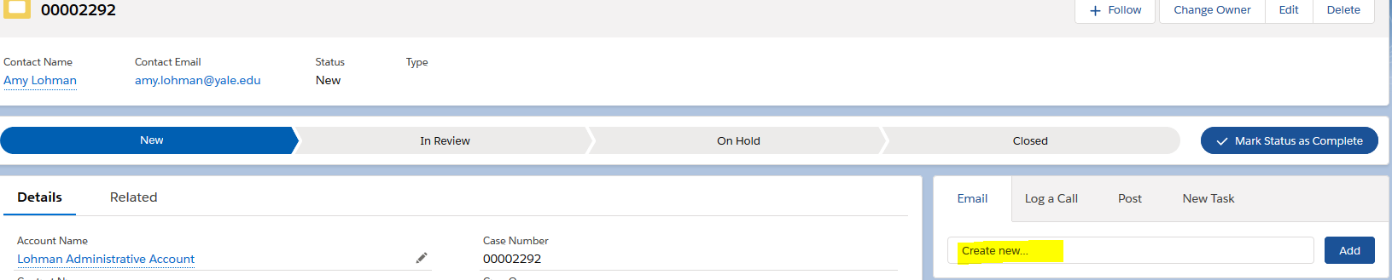

Please remember to enter a “Subject” (it doesn’t prepopulate with the RFP #), enter the Message and then hit Send.
Replies back to the email sent will not automatically come back into the system. For that we have enabled Outlook integration. See the next section to add this module to your Outlook.

Lightning for Outlook Setup
Minimum System Requirements: https://help.salesforce.com/articleView?id=app_for_outlook_system_requirements.htm

- Enable Office 365 Add-in
- Click on this link to get to Manage Add-ins (you will need to login): https://outlook.office365.com/owa/?path=/options/manageapps
- Turn on the Salesforce Add-in by clicking on the Turned On box, see below:
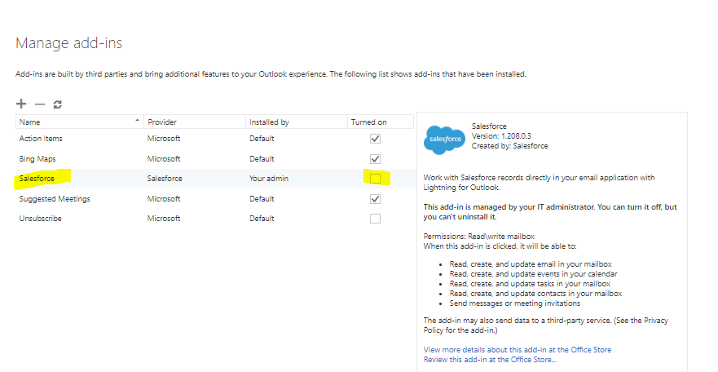

Then when you log into your Outlook you will see this Salesforce icon and you can select the appropriate record to log your email to:

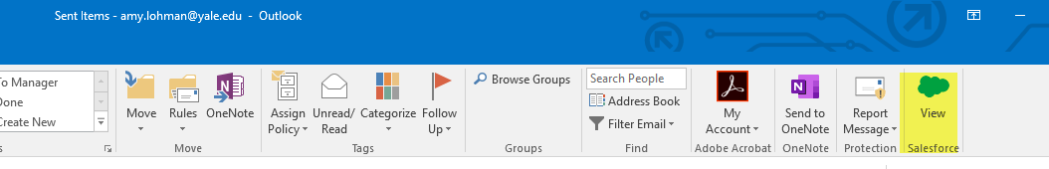
Log a Call:
Search for the name of the person you spoke with…type name and then select.
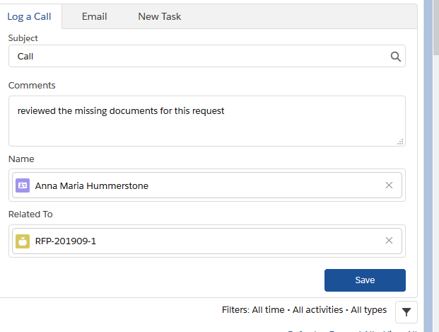

Create Tasks & Assign to other Users:

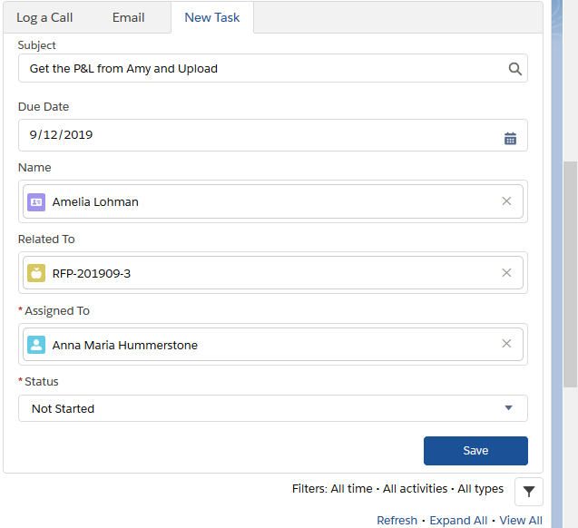

More Reports & Dashboard Training
Users can create their own reports and dashboards….as many as you want!
To get started, please review the training links below:
Explore Reports & Dashboards:
Introduction to Reports and Dashboards in Lightning Experience

Blaze a Trail in Salesforce
Salesforce provides self-based training programs that can help you learn various topics. Here you will find a list of trainings that can help you elevate your experience with the Salesforce platform.
Trailhead Link: https://trailhead.salesforce.com

